**A Deep Learning-Based System to Detect Triple Riding**

**and Helmet Violations Through CCTV Webcam**

***A Project Report submitted***

***in partial fulfillment of the requirements***

***for the award of the degree of***

**BACHELOR OF TECHNOLOGY**

***In***

**COMPUTER SCIENCE & ENGINEERING**

***By***

M. Kavya - 21B01A0591

M. Hema sri - 21B01A0598

L. Harshitha - 21B01A0590

K. S. V. Sahithi - 21B05A0586

M. Tejaswi - 21B01A0592

***Under the esteemed guidance of***

**Dr. T. Gayathri**

**(Professor)**



**DEPARTMENT OF COMPUTER SCIENCE & ENGINEERING**

**SHRI VISHNU ENGINEERING COLLEGE FOR WOMEN(A)**

**(Approved by AICTE, Accredited by NBA & NAAC, Affiliated to JNTU Kakinada)**

**BHIMAVARAM – 534 202**

**2024 – 2025**

**SHRI VISHNU ENGINEERING COLLEGE FOR WOMEN(A)**

**(Approved by AICTE, Accredited by NBA & NAAC, Affiliated to JNTU Kakinada)**

**BHIMAVARAM – 534 202**

**DEPARTMENT OF COMPUTER SCIENCE & ENGINEERING**



**CERTIFICATE**

*This is to certify that the project entitled* ***“A Deep Learning-Based System to Detect Triple Riding and Helmet Violations Through CCTV Webcam”***, *is being submitted* ***by M. Kavya, M. Hema Sri, L. Harshitha, K.S.V. Sahithi, M. Tejaswi*** *bearing* *the* ***Regd. No. 21B01A0591, 21B01A0596, 21B01A0590, 21B01A0586, 21B01A0592***  *in partial fulfillment of the requirements for the award of the degree of “****Bachelor of Technology*** *in* ***Computer Science & Engineering****” is a record of Bonafide work carried out by her under my guidance and supervision during the academic year 2024–2025 and it has been found worthy of acceptance according to the requirements of the university.*

**Internal Guide Head of the Department**

**External Examiner**

# ACKNOWLEDGEMENT

The satisfaction and euphoria that accompany the successful completion of any task would be incomplete without acknowledging the people who made it possible, whose constant guidance and encouragement crowned our efforts with success.

We wish to place our deep sense of gratitude to **Sri. K. V. Vishnu Raju, Chairman of** **Sri Vishnu Educational Society**, for creating excellent academic infrastructure to support this project.

We take this opportunity to express our profound gratitude to **Dr. G. Srinivasa Rao, Principal of SVECW**, **Dr. P. Srinivasa Raju, Director and Admin of SVES**, **Mr. P. Venkata Rama Raju**, **Vice-principal of SVECW** for their constant support and encouragement.

We wish to express our deep sense of gratitude to **Dr. P. Kiran Sree, Head of the Department of Computer Science and Engineering**, for his valuable advice in completing this project successfully.

We are deeply thankful to our project coordinator, **Dr. P. R. Sudha Rani, Professor**, **Department of Computer Science and Engineering**, for her indispensable guidance and unwavering support throughout our project completion. Her expertise and dedication have been invaluable to our success.

We wish to express our sincere thanks to our PRC members **Dr. A. Seenu**, **Mr.** **Y. Ramu,** **and**  **Dr. T. Gayathri**, for their invaluable advices in successfully completing this project.

We sincerely thank our guide, **Dr.T. Gayathri, Professor**, **Department of Computer Science and Engineering**, for providing his valuable suggestions and guidance throughout our project.

Project Associates:

1. M. Kavya - 21B01A0591
2. M. Hema sri - 21B01A0598
3. L. Harshitha - 21B01A0590
4. K. S. V. Sahithi - 21B05A0586
5. M. Tejaswi - 21B01A0592

**ABSTRACT**

The automatic recognition of motorcycle helmets and detection of triple riding violations in real-time surveillance videos is a growing application in computer science. Deep learning techniques for object detection and classification have gained popularity due to their potential to address surveillance-related challenges. However, existing models face limitations in achieving state-of-the-art results due to low resolution, adverse weather, occlusion, and poor illumination. The critical problem of triple riding detection remains inadequately addressed. This study proposes a deep learning-based system utilizing the YOLOv8 model for real-time detection of helmet violations and triple riding infractions using CCTV and webcam footage. While the pre-trained YOLOv8 model is employed for triple riding detection, a custom-trained variant is developed using a dedicated helmet dataset for accurate helmet violation detection. The system processes image and video inputs, generating outputs that visually highlight detected violations. Evaluation metrics such as precision and recall ensure accuracy and reliability. By leveraging publicly available datasets alongside self-collected data, this approach addresses these challenges, delivering robust performance. The proposed system represents a significant advancement in automated traffic rule enforcement, contributing to improved road safety and showcasing the potential of deep learning in surveillance applications. This solution aims to enhance traffic rule enforcement and improve road safety through automated monitoring.

**CONTENTS**

**S. No** **Topic** **Page No**

1. Introduction 7 - 8
2. System Analysis 9 - 12
   1. Existing System
   2. Proposed System
   3. Feasibility Study
3. System Requirements Specification 13 - 15
   1. Software Requirements
   2. Hardware Requirements
   3. Functional Requirements
   4. Non-functional Requirements
4. System Design 16 - 20
   1. Introduction
   2. Workflow Pipeline
   3. Custom trained Helmet detection Architecture Diagram
   4. Custom trained Helmet detection workflow
5. System Implementation 21 - 39
   1. Introduction
   2. Project Modules
   3. Algorithms
   4. Screens
6. System Testing 40 - 55
   1. Introduction
   2. Testing Methods
   3. Test Cases
   4. Results
7. Conclusion 56 - 57
8. Future Scope 58 - 59
9. Bibliography 60 - 61
10. Appendix 62 - 67
    1. Appendix-A
    2. Dataset Description for Helmet Detection
    3. Introduction to Opencv
    4. Introduction to Python Programming

1. **INTRODUCTION**

Road accidents remain a pressing global issue, claiming approximately 1.35 million lives annually and causing injuries to over 50 million individuals, as reported by the World Health Organization. Among the most vulnerable road users are motorcyclists, cyclists, and pedestrians, who lack structural protection, making them more susceptible to severe injuries. Two-wheelers, although an affordable and convenient mode of transport, pose significant safety risks, especially in regions with high traffic density and limited enforcement of road safety regulations. The Traffic Rule Violation Monitoring System ensures that rules are followed strictly while reducing manual effort. The main objective of this work is to identify helmet detection and triple riding violations.

One of the leading causes of motorcycle-related fatalities is head injury, often resulting from the absence of helmets during accidents. Helmets are proven to reduce the impact of collisions, serving as an effective barrier against brain trauma. Despite the critical role of helmets in mitigating injuries, compliance with helmet-wearing regulations remains low in many countries, particularly in developing nations like India and Pakistan. In these regions, factors such as rapid urbanization, insufficient road safety awareness, and unsafe practices like triple riding further exacerbate the risk of accidents.

Most nations recognize the necessity of enforcing road safety regulations but face significant challenges in doing so. Current approaches that rely on manual inspections and human-monitored video surveillance require excessive time and resources, making them difficult to scale effectively. The implementation of artificial intelligence and deep learning provides a viable method to automatically detect safety violations like helmet non-compliance and triple riding in real-time.

This paper presents an object detection system based on deep learning and YOLOv8 (You Only Look Once version 8) to address these challenges. The proposed system analyzes live video feeds from webcams and CCTV cameras to identify motorcyclists riding without helmets and detect triple riding scenarios. By automating monitoring activities, the system eliminates the need for continuous human supervision while ensuring efficient and precise enforcement of road safety regulations.

Integration with existing traffic management infrastructure enhances both scalability and cost-effectiveness. The system can automatically send notifications, fines, and alerts to

individuals who violate rules, ensuring better compliance with road safety regulations while maintaining accountability. The proposed method exhibits robust functionality across various environmental conditions, adapting to lighting changes, occlusions, and weather variations.

The objective of this research is to reduce fatalities and injuries in motorcycle accidents by addressing critical safety infringements. By leveraging advanced deep learning technologies and intelligent traffic systems, the solution contributes to creating smarter and safer urban environments while promoting responsible road usage. Future studies could expand the system’s capabilities to track additional traffic violations and further enhance its functionality, ultimately leading to a comprehensive road safety management solution.

1. **SYSTEM ANALYSIS**
   1. **Existing System**

Traditional traffic monitoring systems rely heavily on human intervention. These systems include manual inspections, physical checkpoints, or human-monitored CCTV footage to detect traffic violations like helmet usage and triple riding. These systems often suffer from the following challenges:

1. **Unsuccessful Real-time Detection :**

Many existing systems struggle to process images and videos in real-time, resulting in delays in violation detection.

1. **High False Positive and False Negative Rates :**

Misclassification of non-riders or irrelevant objects as motorcyclists is common, leading to false positives. Conversely, important violations like helmet non-compliance and triple riding may go undetected (false negatives).

1. **Limited Angle Coverage :**

Traditional systems often fail to detect violations in scenarios where the motorcyclists are not captured in a frontal or side view, which is common in real-world traffic conditions.

1. **Irregular Detection of Moving Objects :**

Difficulty in tracking moving objects, especially in high-traffic situations, results in unclear detection of violations, further complicating enforcement.

1. **Resource and Cost Constraints :**

High resource demands for human inspection, monitoring, and maintenance make these systems costly, especially in regions with limited traffic monitoring infrastructure.

* 1. **Proposed System**

The proposed system is an AI-powered traffic violation detection solution designed to enhance road safety by automating the detection of helmet violations and triple riding on two-wheelers. It leverages deep learning techniques, specifically the YOLOv8 (You Only Look Once) object detection model, to analyze video and image feeds from surveillance cameras in real-time. This ensures high accuracy, efficiency, and reliability in identifying traffic rule violations.

The key features of the system include:

1. **Triple Riding Detection :**

The system utilizes a pre-trained YOLOv8 model to detect instances of triple riding, where more than two people are riding a motorcycle. This feature allows the system to identify dangerous riding practices and issue alerts automatically.

1. **Helmet Violation Detection :**

The YOLOv8 model is custom-trained on a helmet dataset to accurately identify riders not wearing helmets. This ensures that the system can effectively enforce safety regulations by detecting violations in real-time.

1. **Performance Metrics :**

The system provides precision and recall graphs to evaluate the accuracy and reliability of the helmet violation detection. These metrics help in assessing the effectiveness of the model and ensuring that it performs with minimal errors.

1. **Input and Output :**

The system is designed to accept both image and video data as input, allowing it to function in diverse traffic monitoring scenarios. Once the input is processed, the system outputs highlighted images and videos indicating detected violations, making it easy for authorities to review and take action.

1. **Integration with Existing Infrastructure:**

The system is designed for seamless integration with traffic monitoring networks, law enforcement databases, and automated fine systems, making implementation more efficient.

1. **Real-Time Video Processing:**

The system can process live video streams from traffic cameras, detecting violations instantly and reducing the need for manual monitoring.

By automating the violation detection process, the proposed system reduces the need for manual intervention, thereby enhancing enforcement efficiency. The integration of advanced deep learning models ensures that the system performs well even under challenging conditions, such as varying lighting or high traffic density. This makes the proposed solution a robust tool for modern traffic management and law enforcement

**2.3. Feasibility Study**

A feasibility study evaluates the practicality and viability of the proposed system from three key perspectives: Technical Feasibility, Economic Feasibility, and Behavioral Feasibility. The objective is to assess whether the project is technically achievable, financially sustainable, and likely to gain acceptance from all relevant stakeholders.

1. **Technical Feasibility :**

Technical feasibility assesses whether the technology required for the project is available and capable of meeting the system's needs.

* **Advanced Deep Learning Models:** The proposed system uses the YOLOv8 object detection model, which is known for its accuracy and speed. This makes it highly suitable for real-time traffic violation detection, even in complex environments with varying lighting, traffic density, and occlusions.
* **Integration with Existing Infrastructure:** The system is designed to integrate seamlessly with existing surveillance setups, such as CCTV cameras, enabling easy deployment without major overhauls to current infrastructure.
* **Scalability and Flexibility:** The system can process diverse input formats like video and images, which makes it adaptable for different use cases. Additionally, it can run efficiently on mid-tier GPUs or edge devices, making it scalable for both large and small-scale traffic monitoring.
* **Handling Complex Scenarios:** YOLOv8’s capability to detect small objects and work effectively in crowded environments makes it highly suited for detecting helmet violations and triple-riding scenarios, even in high-density traffic or when the violators are partially obscured.

1. **Economic Feasibility**

The economic feasibility considers the financial resources required for the system’s development, deployment, and maintenance, as well as the potential return on investment.

* **Cost-Effective Technology**: The system leverages open-source software like YOLOv8, Python, and OpenCV, which significantly reduces software licensing costs. This ensures that the system can be developed and maintained at a fraction of the cost compared to proprietary solutions.
* **Affordable Hardware Requirements**: The hardware needed for the system, such as GPUs for training and edge devices for deployment, are less expensive than traditional traffic monitoring systems. This makes the proposed solution cost-effective and accessible for various municipalities or traffic authorities with limited budgets.
* **Long-Term Cost Savings**: By automating traffic violation detection, the system reduces the need for manual monitoring and intervention. Over time, this leads to a reduction in labour costs, operational expenses, and increased enforcement efficiency. Additionally, the system can help lower accident rates, thereby reducing medical and legal costs associated with road accidents.
* **Resource Efficiency**: The system’s ability to automatically detect violations and issue penalties ensures that traffic law enforcement is more efficient, helping authorities manage their resources better and focus on other key areas of traffic safety.

1. **Behavioral Feasibility**

The behavioral feasibility evaluates the likelihood of the system’s acceptance by stakeholders, including law enforcement agencies, traffic authorities, and the public.

* **Increased Efficiency and Acceptance**: Automating traffic violation detection reduces human error and reliance on traffic personnel, ensuring more consistent and efficient enforcement. Law enforcement agencies are likely to accept this system for its ability to generate real-time, actionable data and its seamless integration with existing traffic monitoring systems, improving overall workflow.
* **Public Compliance and Awareness**: The real-time detection of violations like helmet usage and triple riding encourages public compliance with traffic laws. Riders are more likely to follow regulations when they know violations are automatically detected and penalized, thus contributing to safer driving behaviors and potentially lowering traffic accidents.
* **Stakeholder Support**: Traffic authorities and law enforcement agencies are likely to support the system due to its potential to enhance enforcement capabilities, improve overall compliance with traffic regulations, and provide valuable insights for policy-making, traffic management, and infrastructure planning.
* **Promoting Safe Road Practices**: By fostering a safer driving environment, the system helps create a culture where road users are more inclined to comply with traffic laws. This ultimately enhances road safety awareness and encourages responsible driving behaviour, contributing to safer roads for all.

1. **SYSTEM REQUIREMENTS SPECIFICATION**

The system requirements specification outlines the hardware and software prerequisites needed for the efficient deployment and functioning of the proposed traffic violation detection system. The system utilizes deep learning techniques for real-time detection of helmet violations and triple riding using the YOLOv8 model.

* 1. **Software Requirements**

Software requirements outline the essential functionalities for the traffic violation detection system. They ensure effective helmet and triple riding detection using YOLOv8 while guiding development, design, and testing for seamless implementation.

* **Programming Language**: Python 3.8 or higher
* **Operating System**: Compatible with Windows 10, macOS, and Linux-based systems supporting Python 3.8
* **Required Libraries**: OpenCV, NumPy, TensorFlow/PyTorch, YOLOv8 model dependencies
* **Data Visualization**: Matplotlib/Seaborn for creating visual representations of data.
* **Code Editor**: Visual Studio Code
  1. **Hardware Requirements**

Hardware requirements define the essential physical components for deploying the traffic violation detection system. They ensure compatibility with YOLOv8 for real-time helmet and triple riding detection, enabling smooth operation and efficient performance.

* **Processor:** Intel Core i5 or higher
* **RAM:** Minimum 8 GB (16 GB for better performance)
* **Storage (ROM):** Minimum 64 GB
* **GPU:** NVIDIA GPU with CUDA support (for faster YOLOv8 inference)
* **Cameras:** High-resolution surveillance cameras for video feed acquisition  
  1. **Functionality Requirements**

Functional requirements define the core operations of the traffic violation detection system. They specify how the system detects helmet violations and triple riding using YOLOv8, processes video and image data, and generates reports for enforcement.

* **Real-time Violation Detection:** The system must detect helmet violations and instances of triple riding in real-time from video and image feeds using the YOLOv8 deep learning model.
* **Data Input:** The system must accept video and image data as input, which can be captured from high-resolution surveillance cameras.
* **Image Preprocessing:** The system should preprocess input data to enhance image quality and optimize it for accurate analysis.
* **Violation Identification:** The system must identify and highlight traffic violations, specifically detecting riders without helmets and triple riding.
* **Violation Reporting:** The system must annotate detected violations and generate real-time reports for enforcement authorities.
* **Performance Metrics**: The system should evaluate detection performance with metrics such as precision and recall, ensuring reliable detection capabilities.
* **User Interface**: The system must include a user-friendly interface for traffic authorities to view violation reports and annotated video/images.
* **Scalability**: The system must be scalable to handle multiple camera feeds simultaneously and adapt to varying traffic conditions.
* **Data Storage**: The system should store detected violations and related metadata in a database for future analysis and reference.
  1. **Non Functional Requirements**

Non-functional requirements define the quality constraints the system must meet, such as accuracy, processing speed, and scalability. These ensure reliable detection of helmet violations and triple riding while maintaining efficiency in real-world conditions.

* **Performance** **:** The system should process video feeds with minimal latency to ensure real-time performance.
* **Scalability :** The system must be scalable to handle multiple video feeds from different CCTV cameras simultaneously.
* **Reliability :** The system should achieve high detection accuracy in diverse scenarios, including varying lighting, weather conditions, and occlusions.
* **Usability :** The interface should be intuitive and easy to use for non-technical users, such as traffic personnel.
* **Maintainability :** The system should be modular, enabling updates to the model or dataset without extensive redevelopment.
* **Compatibility :** The system must be compatible with standard CCTV camera formats and resolutions.
* **Security :** The system should ensure secure handling of video data to protect privacy and prevent unauthorized access.
* **Efficiency :** The system must utilize computational resources optimally, supporting GPU acceleration for training and inference.
* **Portability :** The system should support deployment on various platforms, including local servers, cloud, or edge devices like NVIDIA Jetson.
* **Error Handling :** The system should handle errors gracefully, such as corrupted video files or missing data, by providing meaningful error messages.

1. **SYSTEM REQUIREMENTS SPECIFICATION**
   1. **Introduction**

System design plays a crucial role in the development of an efficient and scalable solution for traffic violation detection. The proposed system leverages deep learning techniques, particularly the YOLOv8 model, to detect helmet violations and triple riding in real-time from video and image feeds.

The design process involves defining the system’s architecture, data flow, components, and processing mechanisms to ensure accurate and efficient detection in real-world scenarios. The system follows a modular approach, allowing seamless integration with existing traffic monitoring infrastructure.

Key aspects of the system design include:

1. **Data Acquisition :**

The system captures real-time video and image feeds from CCTV cameras, dash cams, and mobile recordings at traffic junctions. Proper camera placement, frame rate, and resolution ensure high-quality data for accurate violation detection.

Key considerations in data acquisition:

* Frame Rate & Resolution – Ensuring high-quality footage for accurate detection.
* Camera Placement – Positioning cameras strategically to cover key traffic areas.
* Storage & Transmission – Managing data efficiently for real-time processing.

1. **Preprocessing :**

Captured images and videos undergo enhancements to improve detection accuracy. This includes noise reduction, resizing, normalization, and frame extraction to ensure clear and optimized input for the YOLOv8 model.

* Noise Reduction – Removing unwanted distortions caused by lighting conditions, weather, or motion blur.
* Image Resizing & Normalization – Standardizing input dimensions to match the YOLOv8 model’s requirements.
* Frame Extraction – Selecting relevant frames from video feeds to focus on key moments of traffic activity.

1. **Violation Detection :**

Using YOLOv8, the system detects helmet violations and triple riding in real time. The model processes frames efficiently, distinguishing between riders, vehicles, and surroundings, ensuring high precision even in dense traffic conditions.

* Helmet Violations – Identifying riders who are not wearing helmets.
* Triple Riding – Detecting instances where more than two passengers are on a two-wheeler.

1. **Post-Processing & Reporting :**

Detected violations are annotated with bounding boxes, logged with timestamps and vehicle details, and stored in a database. The system generates automated reports and can be integrated with law enforcement databases for issuing challans, reducing manual intervention and improving compliance.

* Bounding Box Annotation – Marking violators in images or video frames for visualization.
* Automated Reporting – Generating alerts or notifications for traffic authorities, allowing them to take appropriate action.
  1. **Workflow Pipeline**

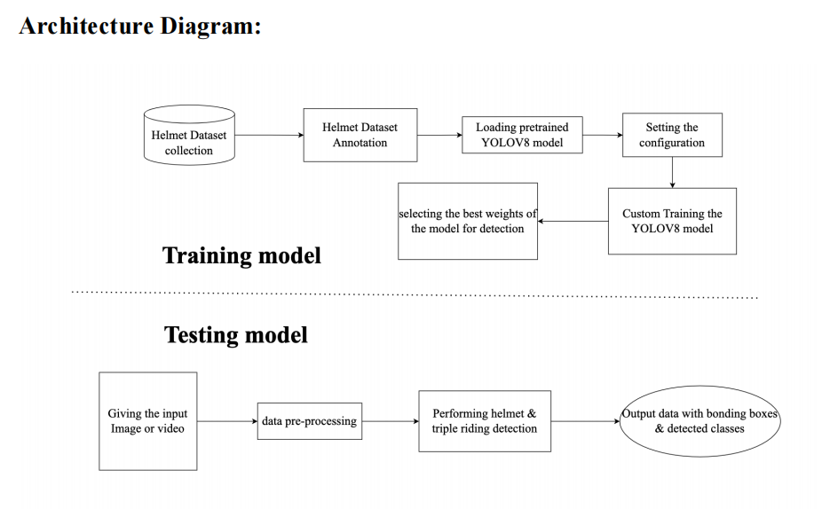 Fig.1. Workflow Pipeline

The architecture diagram presents a structured approach to helmet and triple riding detection using the YOLOv8 model. It is divided into two major phases: **Training Model** and **Testing Model**.

### **Training Model:**

**Helmet Dataset Collection**

* The process starts with collecting a dataset containing images and videos of individuals wearing and not wearing helmets, along with triple riding scenarios.

**Helmet Dataset Annotation**

* The collected data is labeled with bounding boxes and class labels (helmet, no helmet, triple riding, etc.) for supervised learning.

**Loading Pretrained YOLOv8 Model**

* A pre-trained YOLOv8 model is loaded, which has been previously trained on a generic dataset, to fine-tune it for the helmet detection task.

**Setting the Configuration**

* Model parameters such as learning rate, batch size, number of epochs, and augmentation techniques are configured for custom training.

**Custom Training the YOLOv8 Model**

* The model is trained on the annotated dataset to detect helmets and triple riding accurately.

**Selecting the Best Weights for Detection**

* After training, the model's best-performing weights are selected based on evaluation metrics like accuracy, mAP (mean Average Precision), and loss values.

### **Training Model:**

**Giving the Input (Image or Video)**

* The trained model receives an input image or video for inference.

**Data Pre-processing**

* The input is pre-processed, which includes resizing, normalization, and format conversion to match the trained model's input specifications.

**Performing Helmet & Triple Riding Detection**

* The YOLOv8 model runs inference on the pre-processed input, detecting helmets and triple riding instances.

**Output Data with Bounding Boxes & Detected Classes**

* The final output consists of the processed image or video frames with bounding boxes around detected objects, along with their respective class labels.

This structured pipeline ensures an end-to-end workflow for detecting helmets and triple riding using deep learning-based object detection techniques.

* 1. **Custom trained Helmet detection Architecture Diagram:**

**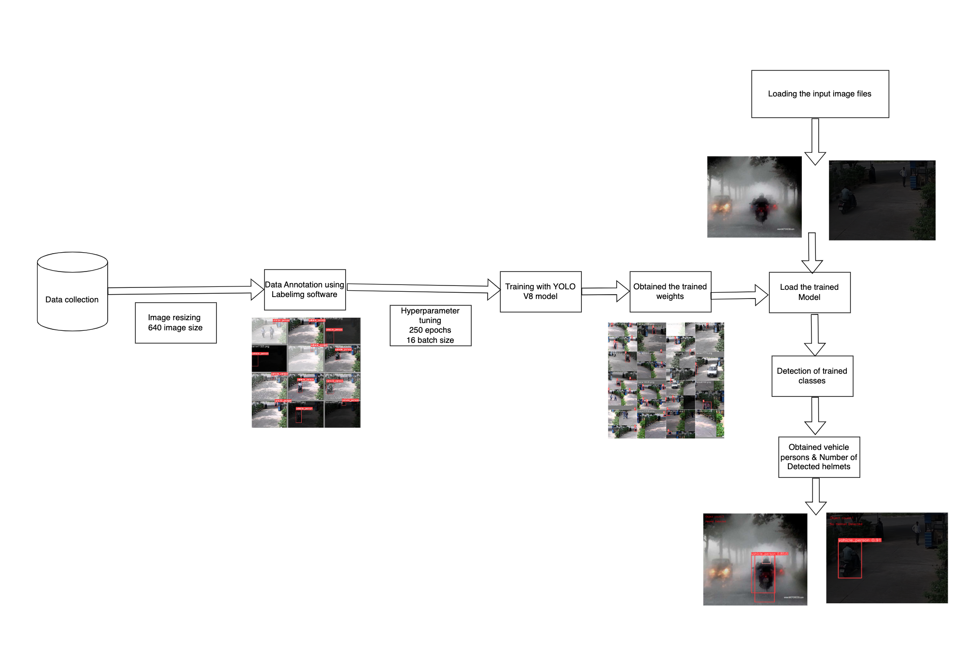**

Fig.2 Custom trained Helmet detection Architecture Diagram

The diagram represents the workflow for detecting helmet violations and triple riding using a YOLOv8-based deep learning model. It starts with data collection, followed by image resizing (640px) and annotation using labeling software. The annotated data undergoes training with YOLOv8, incorporating hyperparameter tuning (250 epochs, 16 batch size) to optimize performance. After training, the model's weights are obtained and used for loading input image files, where the trained model detects vehicles, persons, and helmets. Finally, the system identifies violations by analyzing the detected classes and outputs the results, highlighting instances of non-compliance.

* 1. **Custom trained Helmet detection workflow:**

The flowchart illustrates the helmet detection process using deep learning. It begins with dataset collection, labeling, and splitting into training and validation sets. After selecting a suitable model, the system trains and saves the weights. For testing, input images are processed, and each model undergoes evaluation. The object detection module identifies heads and helmets, followed by a decision-making step that checks if a biker is wearing a helmet. If a helmet is detected, the system classifies the biker as wearing a helmet; otherwise, they are flagged as not wearing a helmet, concluding the process.

**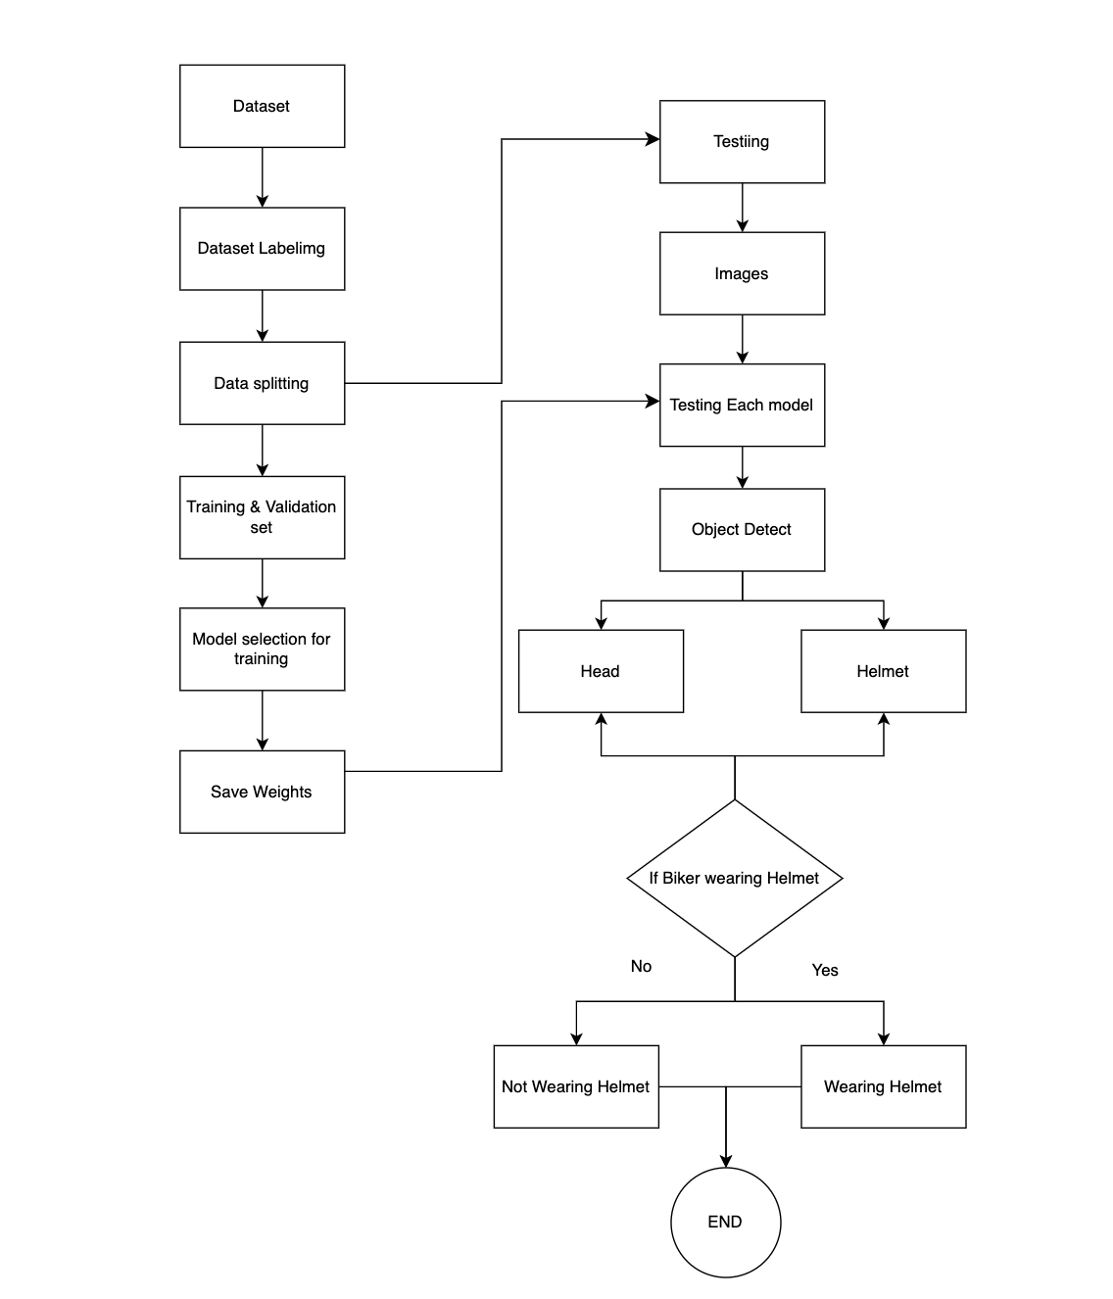**

Fig.3. Custom trained Helmet detection workflow

**5.SYSTEM IMPLEMENTATION**

* 1. **Introduction**

The System Implementation phase represents the actual execution and integration of the AI-powered traffic violation detection system. This system leverages deep learning techniques, specifically YOLOv8, to detect helmet violations and triple riding in real-time from video and image feeds captured by surveillance cameras. The implementation of this system follows a structured approach, consisting of several key phases such as data collection, data preprocessing, model training, evaluation, deployment, and performance monitoring. Below is a detailed explanation of each phase involved in the implementation process.

* 1. **Dataset Overview**

The success of any deep learning model depends significantly on the quality and diversity of the data it is trained on. The dataset for this project is carefully curated to include a variety of traffic scenarios, providing a comprehensive foundation for training and testing the model.

* **Total Images:** The dataset comprises **approximately 600 images**, each representing real-world traffic scenarios, from different environments and lighting conditions.
* **Image Formats:** The dataset includes images in JPEG and PNG formats, which are widely accepted and compatible with the YOLOv8 model.
* **Resolution:** Images in the dataset have varied resolutions, ensuring the model can handle different camera qualities and object sizes in real-world traffic settings.
* **Annotations:** Each image is annotated using the LabelImg tool in the YOLO-compatible format, marking bounding boxes around key objects such as helmets and riders.

**Classes:**

* 1. **Vehicle\_person:** Represents both the motorcycle and its rider, which is essential for detecting the violation of triple riding.
  2. **Helmet:** Identifies whether the rider is wearing a helmet, crucial for detecting helmet violations.
  3. **No\_helmet:** Identifies riders not wearing helmets, marking violations for enforcement purposes.
  4. **Data sources**

The dataset includes a mixture of publicly available datasets and custom-captured  
 data to ensure that the model is exposed to various traffic conditions.

* **Captured Data:** The data is gathered from a variety of sources, primarily from traffic surveillance cameras and publicly available datasets relevant to traffic conditions.
* **Diversity Considerations:**
  1. **Urban and Rural Settings:** The dataset contains images from both urban and rural traffic environments, capturing scenarios typical of both high-density city traffic and quieter rural roads.
  2. **Day and Night**: To ensure the system works under all lighting conditions, the dataset includes images captured during the day and night, accommodating changes in lighting and visibility.
  3. **Traffic Density:** Images represent different levels of traffic density, from light to heavy traffic, ensuring that the system can handle diverse real-world situations, including highly congested roadways.
  4. **Data Preprocessing**

Data preprocessing is a crucial step in preparing the collected data for model training. The goal is to clean, normalize, and augment the dataset to ensure the model can perform optimally in diverse conditions.

* **Annotation of Bounding Boxes:** For each image in the dataset, bounding boxes are drawn around the helmets and riders. This helps the model identify the objects of interest during training.
* **Normalization and Augmentation:**

**Normalization:** The images are standardized to ensure consistency in size, color, and intensity, making the input data uniform and compatible with the YOLOv8 model.

**Augmentation:** Data augmentation techniques, including rotation, scaling, and brightness adjustments, are applied to introduce variation in the data. This improves the model’s ability to generalize to new, unseen scenarios and ensures it can handle changes in camera angles, weather conditions, and lighting.

* 1. **Model Training**

After the data has been pre-processed, the next step is to train the YOLOv8 model using the prepared dataset.

* **Pre-trained YOLOv8 Model:** To expedite the training process and leverage existing knowledge, a pre-trained YOLOv8 model is used. YOLOv8 is an advanced object detection model known for its speed and accuracy in real-time applications.
* **Fine-Tuning YOLOv8 for Helmet Detection**: While YOLOv8 is pre-trained on general object detection tasks, it is fine-tuned on the helmet violation dataset. This allows the model to adapt specifically to the task of helmet detection and triple riding violations.
* **Transfer Learning:** The system employs transfer learning, which allows the model to build upon previously learned features from the pre-trained model. This technique helps improve performance by using knowledge learned from detecting objects in other domains, significantly speeding up training and enhancing the model’s accuracy.
  1. **Model Evaluation**

Once the model has been trained, it is evaluated to assess its effectiveness in detecting violations accurately.

* **Evaluation Metrics:** The performance of the model is evaluated using precision, recall, and F1-score. These metrics help measure the model’s accuracy in detecting violations and its ability to balance false positives and false negatives.
  1. Precision: Measures how many of the detected violations are correct.
  2. Recall: Measures how many of the actual violations were detected.
  3. F1-score: Combines both precision and recall into a single metric to evaluate the overall performance of the model.
* **Precision-Recall Curves:** The model’s performance is analyzed through precision-recall curves. These curves help visualize how well the model performs under various threshold settings and guide in selecting the optimal threshold for violation detection.
  1. **System Deployment**

After training and evaluation, the model is ready to be deployed in a real-time detection system.

* **Real-Time Detection Pipeline:** The trained YOLOv8 model is integrated into a real-time detection pipeline. This allows the system to process live video feeds from traffic surveillance cameras and detect helmet violations and triple riding in real time.
* **Output Generation:** The system generates output images and videos with detected violations highlighted, making it easy for traffic authorities to review and take necessary enforcement actions.
  1. **Performance Monitoring & Optimization**

To ensure the system operates effectively in real-world conditions, continuous monitoring and optimization are performed.

* Continuous Monitoring: The system's performance is continuously monitored to detect potential issues, such as missed violations or false positives. This helps maintain high accuracy and reliability.
* Model Retraining: As the system is deployed in real-world environments, new data will be gathered, and the model will be periodically retrained to improve its performance. This ensures the system adapts to changing traffic conditions and remains accurate over time.
  1. **Continuous Improvement**

To maintain accuracy and effectiveness, the system undergoes continuous updates and enhancements.

* Retraining with New Data: As new traffic data is collected, the model is periodically retrained to improve detection capabilities.
* Algorithm Optimization: Adjustments in the model parameters enhance efficiency and reduce processing time.
* Software Updates: Enhancements are made to ensure compatibility with new camera technologies and evolving traffic regulations.
  1. **Project Modules**

In this project, we leverage deep learning and computer vision techniques to detect **helmet violations** and **triple riding violations** in real-time from video footage. The system uses **YOLO (You Only Look Once)** for object detection, **OpenCV** for image processing, and **IoU-based analysis** to associate detected objects for violation detection.

The project consists of several core modules, each playing a critical role in the detection pipeline. These modules work together to process video frames, identify riders, detect helmets, determine the number of individuals on a bike, and flag violations.

* 1. **OpenCV (cv2)**

OpenCV (Open Source Computer Vision Library) is an open-source computer vision and machine learning library used for real-time image and video processing. It provides tools for handling images, applying transformations, and performing object detection.

**Role in the Project :**

* **Reading and Processing Video:**
  + - cv2.VideoCapture(video\_path): Reads the video frames from the input source.
    - cap.read(): Extracts individual frames for processing.
* **Displaying Results:**
  + - cv2.imshow(): Displays the video output with the detected objects and bounding boxes
* **Drawing Annotations:**
  + - cv2.rectangle(): Draws bounding boxes around detected objects (helmet, people and bikes).
    - cv2.putText(): Adds labels such as "Helmet Detected" or "Triple Riding violation”.
* **Releasing Resources:**
  + - cap.release() and cv2.destroyAllWindows(): Close video files and free system memory after processing.
  1. **Ultralytics YOLO** **(ultralytics.YOLO)**

YOLO (You Only Look Once) is a deep learning-based real-time object detection model that efficiently detects multiple objects in a single pass. The ultralytics package provides an easy-to-use API for training and inference.

**Role in the Project:**

* **Pretrained Model Utilization:** Loads trained YOLO models for helmet detection (YOLO('best.pt')) and triple-riding detection (YOLO('yolov8m.pt')).
* **Real-time Object Detection:** Identifies helmets, people, and bikes from video frames using model.predict(frame, conf=0.6).
* **Bounding Box Extraction:** Retrieves bounding box coordinates (box.xyxy[0].tolist()) and class IDs (box.cls[0]) to determine object types.
* Custom Model Training: Trained a YOLOv8 model with a custom dataset for helmet detection using:
* model.train(data='custom\_data.yaml', imgsz=640, epochs=250, batch=8, name='HelmetViolationDetection-YOLOV8m')
* **Results Visualization:** Plots detected objects with annotations (helmet\_results[0].plot()).
  1. **NumPy (numpy)**

NumPy is a numerical computing library that provides support for multi-dimensional arrays, matrix operations, and mathematical functions.

**Role in the Project:**

* **Handling YOLO Output:** Stores and processes bounding box coordinates extracted from YOLO detections.
* **Efficient Computation:** Converts bounding box outputs into arrays (box.xyxy[0].cpu().numpy()) for faster calculations.
* **Data Manipulation:** Used to filter and process detected objects like helmets, people, and bikes before drawing bounding boxes.
  1. **Intersection over Union (IoU) Function (calculate\_iou)**

IoU (Intersection over Union) is a metric used to measure the overlap between two bounding boxes. It helps in evaluating whether two detected objects (such as a person and a bike) are associated with each other.

**Role in the Project:**

* **Object Association:** Determines whether a detected person is riding a detected bike by checking their IoU score.
* **Violation Detection:** If multiple people have an IoU > 0.1 with the same bike, it is classified as a triple-riding violation.
* **Efficient Filtering:** Reduces false positives by ensuring objects are correctly identified before marking violations.
  1. **Matplotlib (matplotlib.pyplot)**

Matplotlib is a visualization library used for plotting and displaying graphical  
 representations of data.

**Role in the Project:**

* **Plotting Detection Results:** Used to visualize detected objects and verify model performance during testing.
* **Bounding Box Display:** Helps in debugging by manually analyzing detected objects in still frames.
  1. **Algorithms**

The algorithms used in this project are focused on deep learning and computer vision techniques that enable real-time detection of traffic violations such as helmet violations and triple riding. These algorithms leverage powerful machine learning models, particularly object detection models like YOLO (You Only Look Once), to identify and classify objects in video frames with high accuracy. By processing video streams, the system can detect various objects like motorcycles, riders, and helmets, and assess whether riders are wearing helmets or violating the rule of triple riding. The algorithms not only classify and localize objects but also measure performance using metrics such as accuracy, precision, and recall, ensuring that the system is both reliable and efficient. Through continuous learning and adaptation, the algorithms can improve over time, handling diverse real-world scenarios and enhancing traffic law enforcement.

* 1. **Object Detection Algorithm: YOLOv8**

YOLO (You Only Look Once) is a real-time object detection algorithm that detects multiple objects in an image or video frame in a single pass. YOLOv8 is the latest version, offering higher accuracy, efficiency, and speed compared to previous versions.

**YOLOV8** **Working :**

* **Grid-Based Detection:** YOLO divides an input image into a grid of smaller cells. Each cell predicts bounding boxes and class labels for objects.
* **Anchor-Free Approach:** Unlike older versions, YOLOv8 does not rely on predefined anchor boxes, improving detection accuracy.
* **CNN-Based Feature Extraction**: A deep Convolutional Neural Network (CNN) extracts meaningful features from the input image.
* **Bounding Box Prediction:** The model predicts bounding boxes around detected objects along with confidence scores.
* **Non-Maximum Suppression (NMS):** Overlapping detections are filtered, keeping only the most confident ones.
* **Real-Time Processing:** Optimized for high-speed detection, making it ideal for live traffic surveillance.

**Importance :**

* **High Accuracy:** Can effectively detect helmets, motorcycles, and riders.
* **Real-Time Detection:** Optimized for fast inference, crucial for traffic monitoring.
* **Robust to Variability:** Works well under different lighting and weather conditions.
  1. **Image Preprocessing Algorithms :**

Image preprocessing enhances the quality of input images before they are fed into the object detection model. This ensures better feature extraction and improves detection accuracy**.**

**Techniques Used:**

* **Histogram Equalization**
* Enhances the contrast of images, making features more distinguishable.
* Helps in low-light or overexposed conditions.
  + **Image Normalization**
* Scales pixel values to a uniform range (e.g., 0-1 or -1 to 1).
* Prevents large pixel values from dominating the learning process.
  + **Image Augmentation**
* Rotation & Scaling: Increases dataset diversity by rotating and resizing images.
* Brightness Adjustment: Ensures model robustness against different lighting conditions.
* Flipping & Cropping: Introduces variations to improve generalization.

**Importance**

* Improves detection accuracy by providing cleaner and more diverse data.
* Helps the model generalize well to unseen real-world scenarios.
  1. **Performance Evaluation Algorithms :**

After training, the model’s accuracy and reliability must be evaluated. Performance evaluation metrics help determine how well the model detects helmet violations and triple riding.

**Metrics Used :**

* + **Precision**
* Measures how many of the detected violations are actually correct.
* Formula:

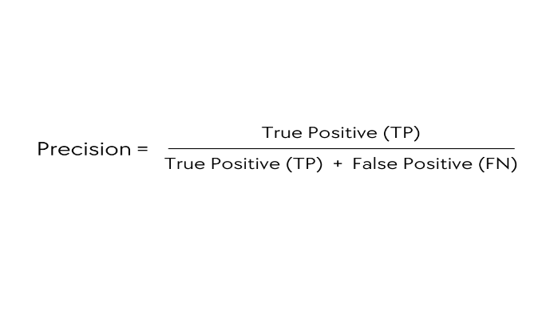

* **High precision** means fewer false alarms.
  + **Recall**
* Measures how many actual violations were detected.
* Formula:

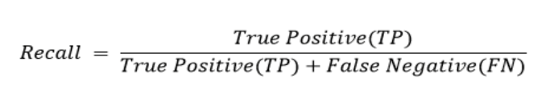

* **High recall** means fewer missed detections.
* **F1-Score**
* A balance between precision and recall.
* Formula:

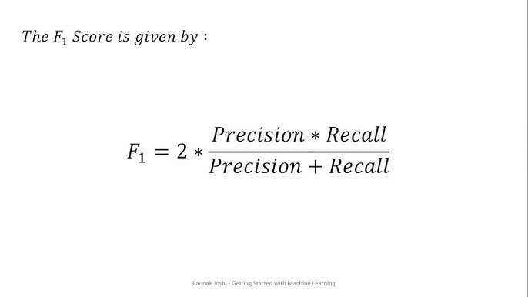 ​

* **Higher F1-score** indicates a well-balanced model.
* **Precision-Recall Curve**
* Shows the trade-off between precision and recall at different confidence thresholds.
* Helps choose the best confidence threshold for optimal performance.

**Importance :**

* Ensures the system detects violations accurately without too many false positives.
* Helps in fine-tuning the model for real-world deployment.
* **Architecture of YOLOV8**

YOLOv8 (You Only Look Once, Version 8) is a state-of-the-art real-time object detection model that builds upon its predecessors by introducing several key innovations. It enhances accuracy, speed, and efficiency, making it ideal for applications like traffic monitoring, where quick and precise detections are necessary. In this project, YOLOv8 is employed to detect helmet violations and triple riding in real-time, ensuring effective law enforcement and road safety.

The YOLOv8 architecture is divided into three main components: Backbone, Neck, and Head. Each of these plays a crucial role in object detection.

1. **Backbone** **(Feature Extraction):**

**Purpose:** The backbone is responsible for extracting essential features from the input image.

**Technology Used:**

* YOLOv8 uses a modified version of CSPDarknet53, a powerful feature extraction network.
* CSPNet (Cross Stage Partial Network) enhances computational efficiency by splitting feature maps and enabling parallel processing.
* It captures multi-scale information from the input image, which helps detect objects of various sizes.

1. **Neck(Feature fusion) :**

**Purpose:** The neck combines the extracted features from different layers of the backbone to improve object detection.

**Technology Used:**

* It uses Path Aggregation Network (PANet), which enhances feature fusion.
* PANet helps in merging fine-grained (low-level) details with high-level semantic features, improving detection accuracy across different scales.
* This is particularly important in helmet and triple riding detection, where small details like helmet presence need to be accurately classified**.**

1. **Head(Final Predictions) :**

**Purpose:** The head processes the features from the neck and predicts object class, bounding boxes, and confidence scores.

**Technology Used:**

* YOLOv8 employs an **anchor-free mechanism**, meaning it does not rely on predefined anchor boxes.
* Instead, it directly predicts the object location and class, making training and inference more efficient.
* This simplifies the object detection process and enhances model generalization, making it more adaptable to real-world traffic scenarios.
* **Advantages of YOLOV8**

The high-end features of YOLOv8 make it an excellent choice for detecting helmet violations and triple riding in real-time.

1. **Real-Time Performance**
   * YOLOv8 is optimized for high-speed processing, making it ideal for real-time traffic monitoring applications.
   * It can process video feeds quickly, detecting violations instantly.
2. **High Accuracy**
   * Improved feature extraction and detection algorithms enhance precision and recall.
   * This ensures accurate detections even under difficult conditions, such as poor lighting or crowded roads.
3. **Flexibility**
   * YOLOv8 is compatible with various datasets and can be customized for specialized applications.
   * Whether detecting helmets, multiple riders, or other traffic violations, the model can be adapted to fit different requirements.

These features position YOLOv8 as a powerful tool for complex object detection challenges, including helmet and triple riding violation detection in traffic monitoring systems.

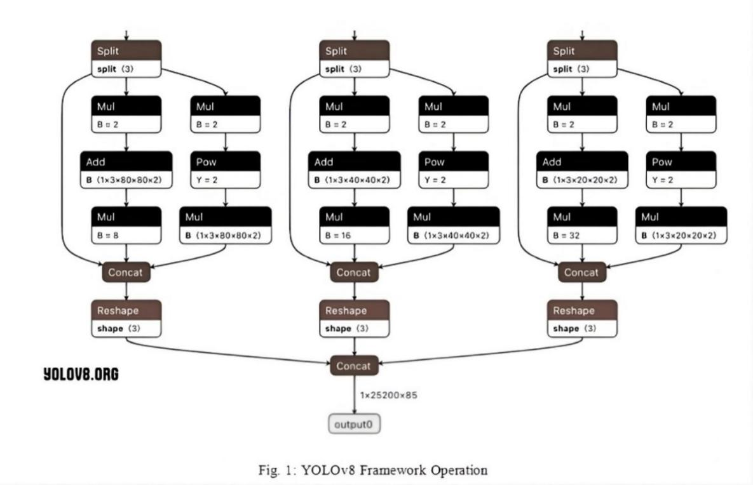

Fig.4. YOLOv8 Framework Operation

* **YOLOv8 Key Innovations**

1. **Anchor-Free Prediction**

* Unlike older versions of YOLO that relied on anchor boxes, YOLOv8 eliminates them, simplifying both training and inference.
* This reduces computational overhead and makes the model more flexible in detecting objects of varying sizes.

1. **Dynamic Input Resizing**

* YOLOv8 can process images of different resolutions during training.
* This improves robustness, allowing the model to handle images captured in various conditions (e.g., different camera angles, lighting variations).

1. **Modular Design**

* YOLOv8 supports multiple tasks such as object detection, classification, and segmentation.
* It achieves this using task-specific prediction heads optimized for each type of task.

1. **Transfer Learning Support**

* The model allows fine-tuning on custom datasets, making it suitable for specific applications like helmet and triple riding detection.
* By training on specialized traffic datasets, the model improves its accuracy in recognizing motorcyclists and detecting violations.

1. **Lightweight Architecture**

* YOLOv8 is designed to be computationally efficient, making it suitable for deployment in real-time traffic monitoring systems.
* Despite its efficiency, it maintains high accuracy, ensuring reliable detection under challenging conditions.
* **YOLOv8 in Helmet and Triple Riding Detection**

In this project, YOLOv8 is trained on a dataset containing images of motorcyclists wearing helmets, without helmets, and with multiple riders. The model processes video frames, detecting and classifying:

1. Whether the rider is wearing a helmet.
2. Whether the motorcycle has more than two riders (triple riding violation).

**The output includes:**

* Bounding boxes around detected objects.
* Class labels (helmet/no helmet, number of riders).
* Confidence scores indicating the reliability of the detections.
  1. **Screens**

**Detections on the images**

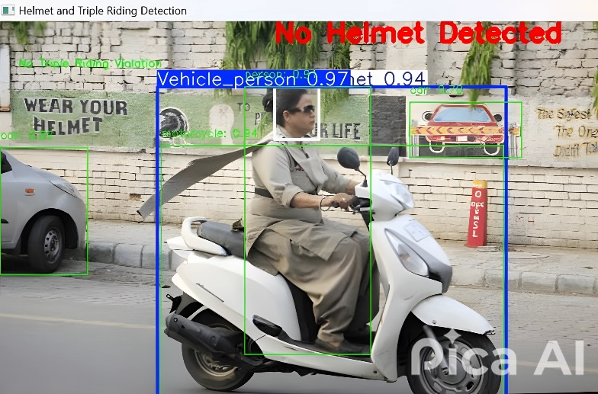

Fig.5. Helmet Violations Detected on single vehicle

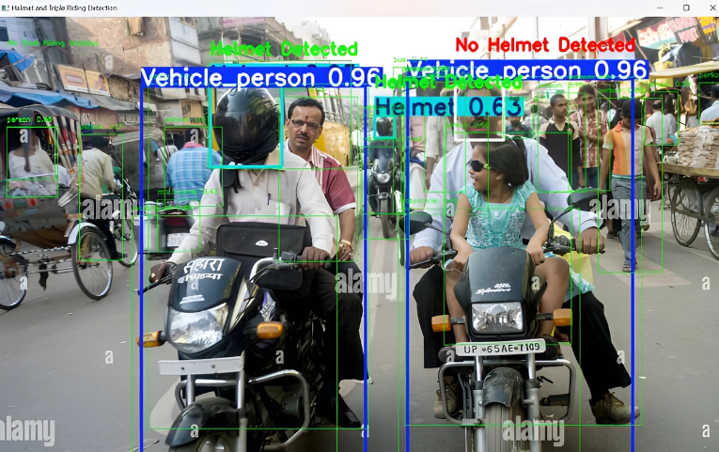

Fig.6. Helmet Violations detected on multiple vehicles

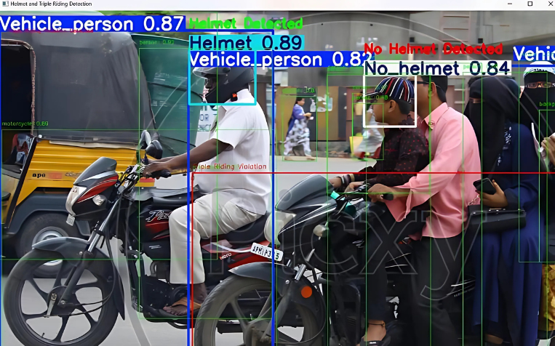

Fig.7. Triple Riding Violation Detected

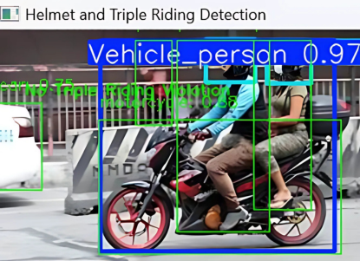

Fig.8. No Triple Riding Violation Detected

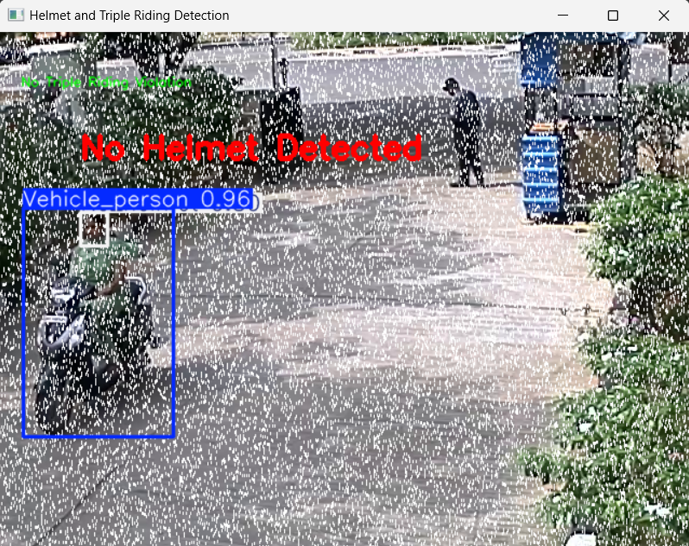

Fig.9. Helmet Violation Detected in Rainy weather Conditions

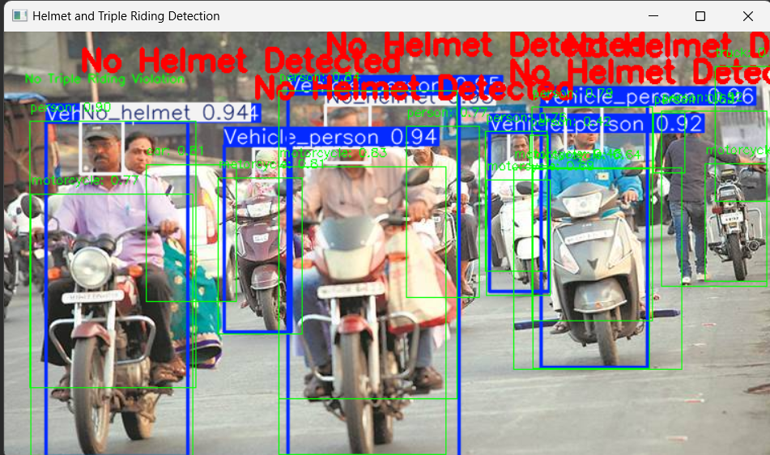

Fig.10. Helmet Violations Detected on multiple vehicles

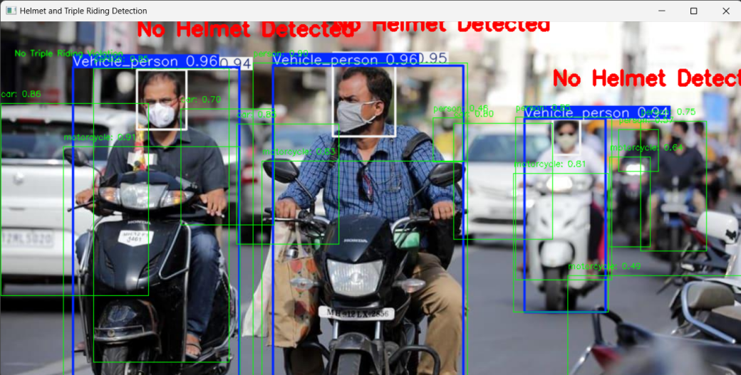

Fig.11. No Helmet and Triple Riding Violations Detected

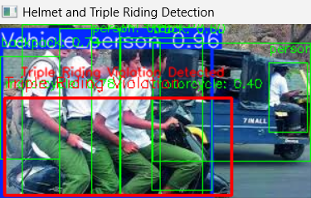

Fig.12. Triple riding Violations Detected

The processed images output include **detected persons, motor cycles, helmets, and triple riding violations**, with each identified object enclosed in a **bounding box**. The system assigns a **confidence score** to each detection, indicating the accuracy of classification. If a **helmet violation** is found, the image will be annotated accordingly and displaying with a message. Similarly, if a **triple riding violation** is detected, it will be highlighted. In cases where no violations are found, the image will reflect normal riding behavior. The model ensures reliable detection even under **challenging conditions**, such as **rainy weather**, maintaining high accuracy in various environments.

**Detections on the videos**

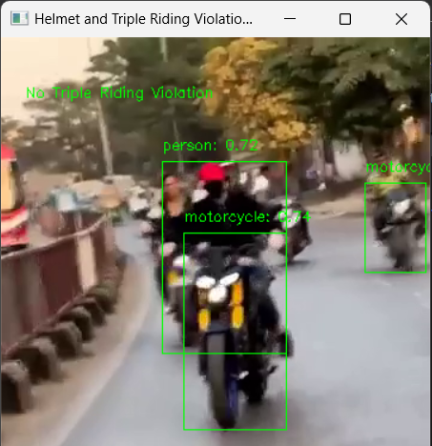

Fig.13. Detections on the video

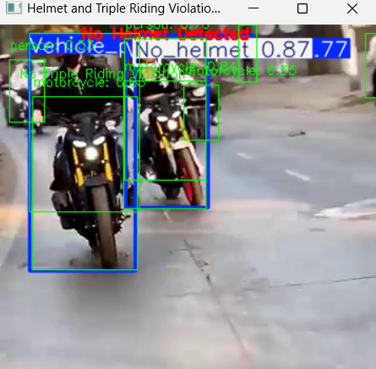

Fig.14. Helmet and Triple riding violations detected on the video

|  |  |
| --- | --- |
|  |  |
|  |  |

Fig.15. Detections on the video

For videos, the system performs **real-time detection** of **persons, helmets, and triple riding violations**, similar to image processing. Each frame of the video is analyzed individually, with **bounding boxes** marking detected objects and confidence scores indicating accuracy. The system continuously tracks violations, such as **helmet non-compliance and triple riding**, ensuring consistent detection across multiple frames. Annotated screenshots from the video highlight detected violations, providing a clear visual representation of the results.

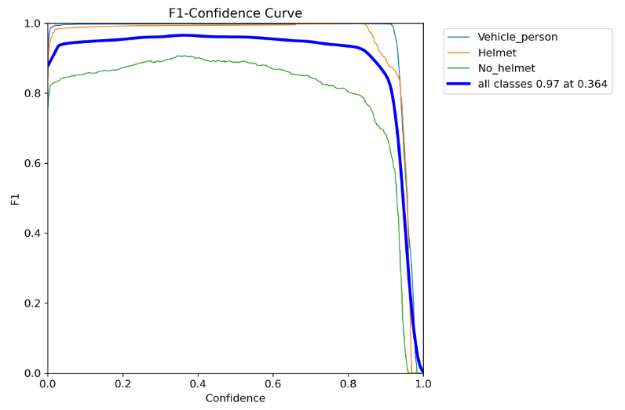

Fig.16. F1-Confidence Curve

The **F1-Confidence Curve** illustrates the model's performance across different confidence thresholds for detecting **persons, helmets, and helmet violations**. The model achieves an optimal **F1-score of 0.97 at a confidence of 0.364**, ensuring a balanced trade-off between precision and recall. Helmet detection performs the best, while **"No Helmet" detection** shows a gradual drop, indicating potential room for improvement. This curve helps in selecting the ideal confidence threshold for accurate violation detection.

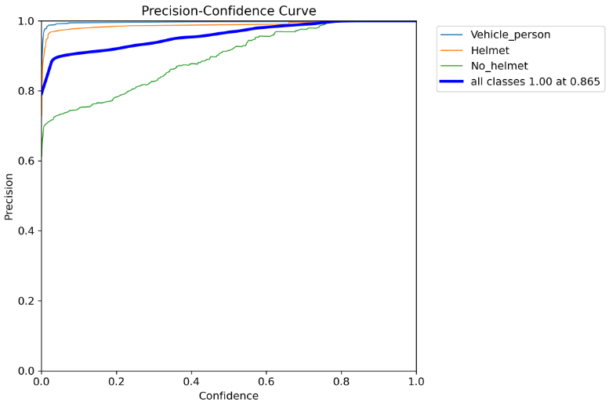

Fig.17. Precision-Confidence Curve

The **Precision-Confidence Curve** shows the model's precision across different confidence thresholds for detecting **persons, helmets, and helmet violations**. The model achieves **100% precision at a confidence threshold of 0.865**, meaning it minimizes false positives at this level. Helmet detection performs the best, while **"No Helmet" detection** has a lower precision at lower confidence values but improves as confidence increases. This curve helps in selecting an optimal confidence threshold for highly accurate violation detection.

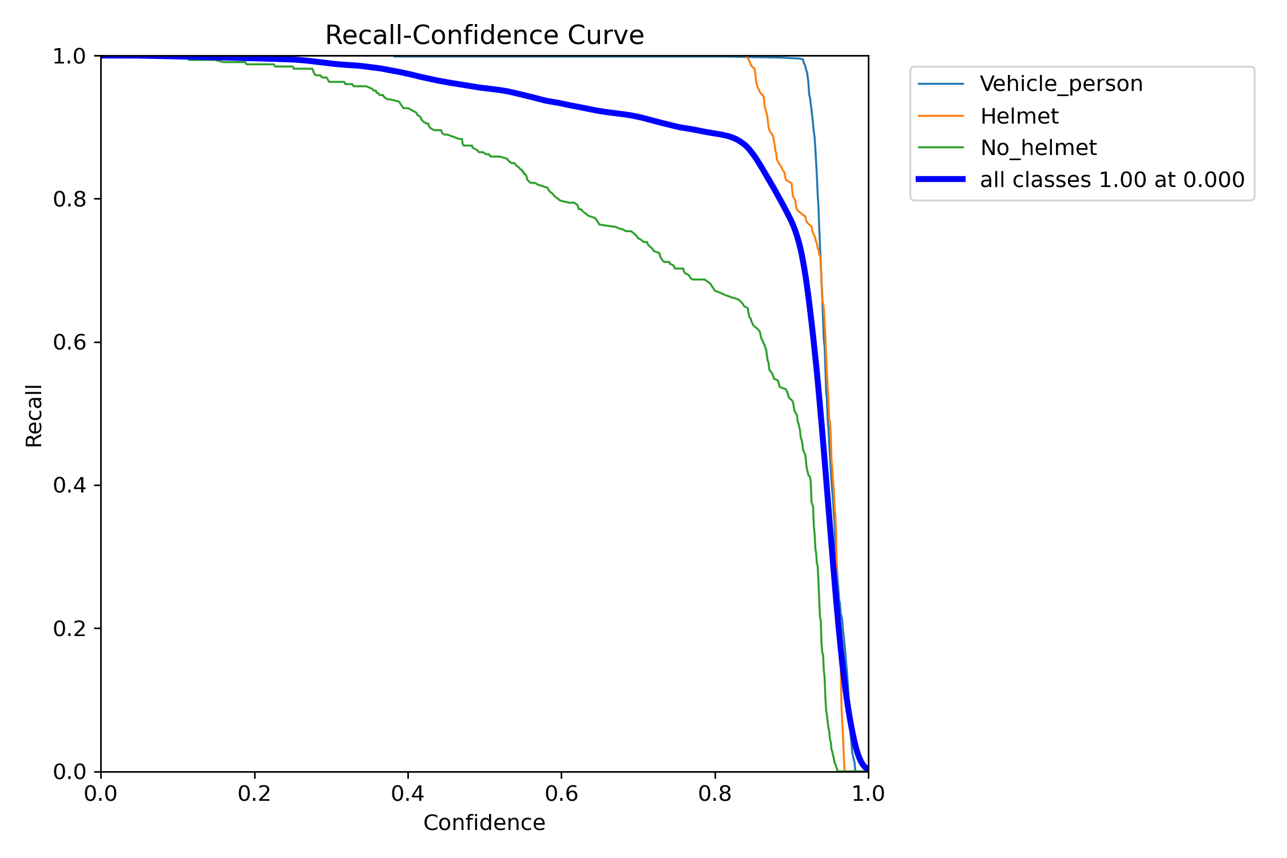

Fig.18. Recall-Confidence Curve

The **Recall-Confidence Curve** illustrates how recall changes with varying confidence thresholds for detecting **persons, helmets, and helmet violations**. The model achieves **100% recall at a confidence threshold of 0.000**, meaning it captures all relevant detections but may include false positives. As confidence increases, recall declines, particularly for **"No Helmet" detection**, indicating that stricter confidence thresholds might miss some violations. This curve helps in selecting a balance between recall and precision for optimal detection performance.

1. **SYSTEM TESTING**
   1. **Introduction**

Software testing is an essential phase in the Software Development Life Cycle (SDLC), ensuring that an application functions as expected and meets user requirements. It plays a critical role in improving software quality by identifying and fixing defects before deployment. Among the various testing levels—unit testing, integration testing, system testing, and acceptance testing—system testing is particularly important as it evaluates the software as a complete and integrated system.

Testing is the process of trying to discover every conceivable fault or weakness in a work product. It provides a way to check the functionality of components, subassemblies, assemblies and/or a finished product It is the process of exercising software with the intent of ensuring that the Software system meets its requirements and user expectations and does not fail in an unacceptable manner.

The purpose of testing is to discover errors. Testing is the process of trying to discover every conceivable fault or weakness in a work product. It provides a way to check the functionality of components, sub-assemblies, assemblies and/or a finished product It is the process of exercising software with the intent of ensuring that the Software system meets its requirements and userexpectations and does not fail in an unacceptable manner. There are various types of test. Each test type addresses a specific testing requirement.

There are various types of tests. Each test type addresses a specific testing requirement. Software Testing is evaluation of the software against requirements gathered from users and system specifications. Testing is conducted at the phase level in software development life cycle or at module level in program code. Software testing comprises of Validation and Verification.

System Testing is basically performed by a testing team that is independent of the development team that helps to test the quality of the system impartially.

Usually, software testing includes:

* **Unit tests:** The program is broken down into blocks, and each element (unit) is tested separately.
* **Integration tests:** This type of testing observes how multiple components of the program work together. Then, to evaluate the performance of the model in machine learning, we use two sets of data:
* **Validation set:** Having only a training set and a testing set is not enough. And that can result in overfitting.
  + **Test set:** Our model might fit the training dataset perfectly well. But where are the guarantees that it will do equally well in real-life? In order to assure that, you select samples for a testing set from our training set, that the machine hasn’t seen before

The basic goal of the software development process is to produce software that has no errors or very few errors. We have seen that different levels of testing are needed to detect the defects injected during the various tasks in the project. The testing process for a project consists of three high-level tasks test planning, test case design, and test execution. We will discuss these in the rest of this section.

* 1. **Test Planning**

The first step in system testing is defining the **test plan**, which outlines the **scope, objectives, schedule, and resources** for testing. A well-defined test plan ensures that testing efforts are aligned with project goals and that all critical areas of the system are covered.

The inputs for forming the test plan are:

* Project plan
* Requirements document
* Architecture or design document.
  1. **Test Case Design**

Test cases are designed based on system requirements, specifying input conditions, expected outcomes, and different real-world scenarios. Well-structured test cases help testers systematically verify various functionalities and identify defects efficiently.

* 1. **Test Case Execution**

The test case specifications only specify the set of test cases for the unit to be tested. However, executing the test cases may require construction of driver modules or stubs. It may also require modules to set up the environment as stated in the test plan and test case specifications.

* 1. **Testing Methods**

Software testing is a crucial phase in the software development life cycle that ensures the system is functioning correctly, efficiently, and securely. It involves evaluating different components of a system to identify potential defects, errors, or weaknesses before deployment. The Helmet Violation and Triple Riding Detection System using YOLOv8 requires a robust testing strategy to guarantee its reliability and effectiveness in real-world conditions. The following sections provide a detailed explanation of different testing methodologies, their approaches, and their applications in the project.

System Testing includes testing of a fully integrated software system. Generally, a computer system is made with the integration of software (any software is only a single element of a computer system).

The software is developed in units and then interfaced with other software and hardware to create a complete computer system. In other words, a computer system consists of a group of software to perform the various tasks, but only software cannot perform the task; for that software must be interfaced with compatible hardware. System testing is a series of different types of tests with the purpose to exercise and examine the full working of an integrated software computer system against requirements.

To check the end-to-end flow of an application or the software as a user is known as System testing. In this, we go through all the necessary modules of an application and check if the end features or the end business works fine, and test the product as a whole system. It is end-to-end testing where the testing environment is similar to the production environment.

There are mainly two widely used methods for software testing, one is White box testing which uses internal coding to design test cases and another is black box testing which uses GUI or user perspective to develop test cases.

The following are the Testing Methodologies:

* + - White box Testing.
    - Black box Testing.
    - Unit Testing.
    - Integration Testing.
    - Validation Testing.
  1. **White Box Testing**

White Box Testing, also known as Glass Box Testing or Clear Box Testing, is a testing methodology where the internal structure, code, and logic of the system are evaluated. The tester has full visibility into the source code and can analyze how inputs are processed, how functions interact, and how data flows within the system. This type of testing is generally conducted by developers who understand the internal workings of the software and aim to optimize performance, security, and efficiency.

White Box Testing is particularly useful in identifying logical errors, security vulnerabilities, broken paths, and unoptimized loops that may affect the system's execution. Since this testing examines the internal code structure, it requires knowledge of programming languages, frameworks, and algorithms used in development.

**Approaches to Black Box Testing :**

1. **Equivalence Partitioning:** Divides input data into valid and invalid partitions and tests representative values from each group.
2. **Boundary Value Analysis:** Focuses on input values at the edges of the allowable range to detect errors.
3. **Decision Table Testing:** Uses tables to test different input conditions and their expected outputs.
4. **State Transition Testing**: Examines how the system responds to different states or transitions, such as switching between different modes in real-time applications.

**Techniques Used in White Box Testing :**

1. **Statement Coverage** : Ensures every line of code is executed at least once.
2. **Branch Coverage** : Tests all decision-making branches (if-else, switch-case).
3. **Path Coverage** : Examines all possible execution paths.
4. **Loop Testing** : Checks loop conditions, iterations, and termination.
5. **Data Flow Testing** : Analyzes variable usage to prevent undefined behaviors.

**Applications of White Box Testing in the Project :**

1. **Testing Feature Extraction in YOLOv8:**
   * The project uses YOLOv8 for object detection. White box testing helps ensure that the feature extraction process is correctly implemented.
   * It verifies whether the convolutional layers correctly identify edges, shapes, and helmet presence.
2. **Validating Preprocessing Techniques:**
   * The input images go through multiple preprocessing steps, including grayscale conversion, image resizing, and normalization.
   * This testing ensures that these operations are performed efficiently without data loss or distortion.
3. **Debugging Bounding Box Calculations:**
   * YOLOv8 generates bounding boxes around detected objects. White box testing checks the calculations involved in bounding box placement, size, and confidence scores.
   * It ensures that the bounding boxes are accurately positioned over helmets and triple riders.
4. **Verifying Data Flow and API Responses:**
   * The detection system interacts with a database and API endpoints for data storage and retrieval.
   * White box testing ensures queries and API responses return the expected data.
5. **Black Box Testing**

Black Box Testing is a functional testing technique where the tester evaluates the system's behaviour **without knowledge of its internal code or structure**. Instead of analyzing how the software works internally, testers focus on whether the system produces the correct outputs for given inputs. This approach is commonly used to **validate the functionality of the system, ensure compliance with requirements, and detect usability issues** that may impact end users.

Black Box Testing is particularly effective in testing **user interfaces, APIs, databases, and object detection results.** It helps ensure that the system behaves correctly under normal conditions and handles invalid inputs gracefully.

**Approaches to Black Box Testing :**

1. **Equivalence Partitioning:** Divides input data into valid and invalid partitions and tests representative values from each group.
2. **Boundary Value Analysis:** Focuses on input values at the edges of the allowable range to detect errors.
3. **Decision Table Testing:** Uses tables to test different input conditions and their expected outputs.
4. **State Transition Testing:** Examines how the system responds to different states or transitions, such as switching between different modes in real-time applications.

**Techniques Used in Black Box Testing :**

1. **Equivalence Partitioning** : Divides inputs into valid and invalid groups and tests representative values.
2. **Boundary Value Analysis** : Focuses on edge-case inputs near boundary limits.
3. **Decision Table Testing** : Uses tables to verify system behaviour under different conditions.
4. **State Transition Testing** : Evaluates system responses to state changes.
5. **Error Guessing** : Involves guessing potential failure points based on experience.

**Applications of Black Box Testing in the Project :**

1. **Testing Detection Accuracy with Different Input Scenarios:**
   * The system is tested with images of varying quality, lighting conditions, and angles.
   * Ensures the detection algorithm works accurately in real-world conditions.
2. **Evaluating Performance on Different Vehicle Types:**
   * The model is tested to recognize different vehicle types (bikes, scooters, etc.) to ensure consistency.
   * The system should be able to differentiate between a helmeted rider and a person wearing a cap or hood.
3. **Verifying System Behaviour for Unexpected Inputs:**
   * Tests how the system responds to blurred images, low-light conditions, or occlusions.
   * Ensures the system does not generate false positives or false negatives frequently.
4. **Checking Output Validity for Law Enforcement Reports:**
   * Ensures that detection reports generated by the system contain accurate timestamps, vehicle numbers, and violation details.
5. **Unit Testing**

Unit Testing is a fundamental testing method that focuses on evaluating individual **components, functions, or modules** of the software in isolation. The primary goal is to verify that each unit performs as expected before integrating it with other components. This approach helps detect errors at an early stage, reducing the complexity of debugging in later phases.

Unit Testing is typically performed by developers using testing frameworks such as **PyTest (for Python), JUnit (for Java), or Unit test (for Python).** Each test case is designed to test a specific function, ensuring that it returns correct results under various conditions.

**Approaches to Unit Testing :**

* 1. **White Box Approach :** Tests internal code logic, control flow, and error handling.
  2. **Black Box Approach :** Focuses on input-output validation without analyzing internal implementation.
  3. **Automated Unit Testing :** Uses testing frameworks to automate test execution and validation.
  4. **Mocking and Stubbing Approach :** Simulates external dependencies to isolate and test specific functions.

**Techniques Used in Unit Testing**

1. **Test-Driven Development (TDD)** : Writing test cases before coding the actual function.
2. **Mocking and Stubbing** : Using fake data or components to isolate tests.
3. **Assertion Testing** : Verifying expected vs. actual output using assertions.
4. **Automated Unit Tests** : Using testing frameworks like PyTest, JUnit, or Unittest.

**Applications of Unit Testing in the Project**

1. **Testing Image Preprocessing Functions:**
   * Ensures that image resizing, normalization, and filtering functions work as expected.
   * Each transformation applied to the image is checked for accuracy and efficiency.
2. **Checking Individual Layers of YOLOv8 Model:**
   * The backbone, neck, and head layers of YOLOv8 are tested separately.
   * This ensures that each layer extracts relevant features before passing them to the next stage.
3. **Verifying Database Queries:**
   * Ensures that when a helmet violation is detected, the data is correctly stored in the database.
   * Tests read and write operations for speed, correctness, and efficiency.
4. **Unit Testing of Alert Generation System:**
   * Ensures that once a violation is detected, the system triggers the correct alert or notification.
   * Tests email/SMS alerts and verifies whether they contain the correct violation details.
5. **Integration Testing**

Integration testing addresses the issues associated with the dual problems of verification and program construction. After the software has been integrated a set of high order tests are conducted. The main objective in this testing process is to take modules and builds a program structure that has been dictated by design. Integration Testing is defined as a type of testing where software modules are integrated logically and tested as a group. A typical software project consists of multiple software modules, coded by different programmers. The purpose of this level of testing is to expose defects in the interaction between these software modules when they are integrated. Integration Testing focuses on checking data communication amongst these modules.

**Approaches to Integration Testing**

1. **Top-Down Integration:** Tests higher-level modules first, gradually integrating lower-level ones.
2. **Bottom-Up Integration:** Tests lower-level modules first, integrating them into higher-level ones step by step.
3. **Big Bang Integration:** Combines all components simultaneously for a single round of testing.
4. **Incremental Integration:** Integrates and tests components progressively in small groups.

**Techniques Used in Integration Testing**

1. **Top-Down Integration** : Testing starts from the top module and integrates downward.
2. **Bottom-Up Integration** : Lower-level modules are tested first and then integrated.
3. **Big Bang Integration** : All components are combined and tested at once.
4. **Incremental Integration** : Modules are integrated in phases to simplify debugging.

**Applications of Integration Testing in the Project**

1. **Validating Image Input to YOLOv8 Model:**

* Ensures the image pipeline correctly sends frames to the model for processing.
* Checks whether frames are captured and processed **without delay or loss**.

1. **Testing Communication Between Detection Module and Database:**

* Ensures that once a violation is detected, data is correctly stored and retrieved from the database.
* Checks whether timestamps, violation types, and images are correctly linked in the database.

1. **Integration of API and Web Interface:**

* Ensures that the detection system correctly interacts with APIs used to display violation reports.
* Tests whether the web interface fetches real-time detection data without errors.

1. **Ensuring Correct Functionality of the Alert System:**

* Checks if alerts are generated and sent to law enforcement or users when violations are detected.
* Ensures email, SMS, and app notifications work correctly across platforms.

1. **Validation Testing**

The process of evaluating software during the development process or at the end of the development process to determine whether it satisfies specified business requirements. Validation Testing ensures that the product actually meets the client's needs. It can also be defined as to demonstrate that the product fulfills its intended use when deployed on appropriate environment.

**Approaches of Validation Testing :**

1. **Requirement-Based Testing :** Ensures the system meets all specified functional and business requirements.
2. **Functional Validation :** Verifies that the core functionalities perform as expected, such as object detection and classification.
3. **User Acceptance Testing (UAT) :** Engages end-users to confirm that the system aligns with real-world usage scenarios.
4. **Regression Validation :** Ensures that new changes do not disrupt previously validated system functionalities.

**Techniques Used in Validation Testing**

1. **Functional Testing** : Ensures all features work as specified.
2. **Usability Testing** : Evaluates user experience and system usability.
3. **Performance Testing** : Measures system speed and resource efficiency.
4. **Security Testing** : Identifies vulnerabilities and data protection mechanisms.
5. **Acceptance Testing** : Confirms system meets business needs and end-user requirements.

**Applications of Validation Testing in the Project**

1. **Ensuring Helmet Violation and Triple Riding Detection Works in Real Traffic Conditions:**
   * The system is tested in various lighting, weather, and traffic conditions.
   * Ensures detection remains accurate even when multiple vehicles are present.
2. **Performance Testing on Large-Scale Video Feeds:**
   * The system is tested on high-resolution CCTV footage to ensure it can handle large-scale video input.
   * Measures frame processing speed and model response time.
3. **Usability Testing for Law Enforcement Officers:**
   * Ensures the system interface is user-friendly and displays violation details clearly.
   * Law enforcement officers should be able to quickly access detected violations and generate reports.
4. **Security Testing for Data Protection:**
   * Ensures that violation images and personal data are securely stored.
   * Tests encryption and access control mechanisms to prevent unauthorized data access.
   1. **Testing Cases**

### **1. Input Handling Test Cases**

**Valid Input**: Provide a clear image/video with people wearing helmets and check if detection works.

* On Image

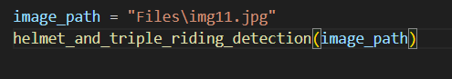

Fig.19. Given Valid Path

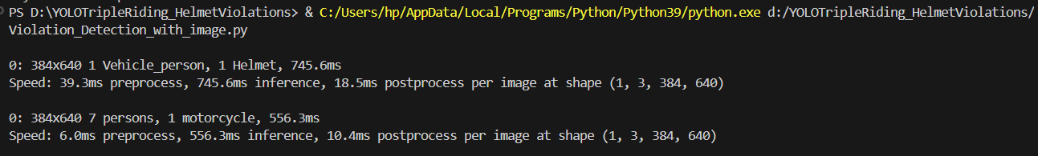

Fig.20. Valid Execution

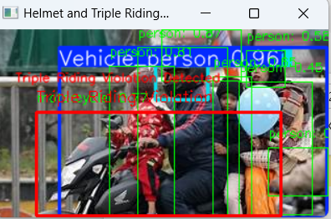

Fig.21. Valid Detections

* On Video

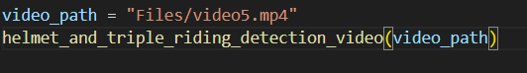

Fig.22. Given Valid Path

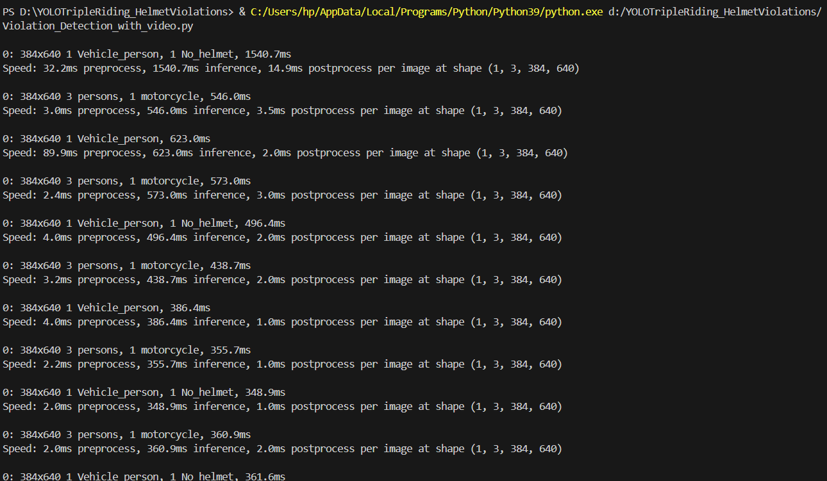Fig.23. Valid Execution on each frame

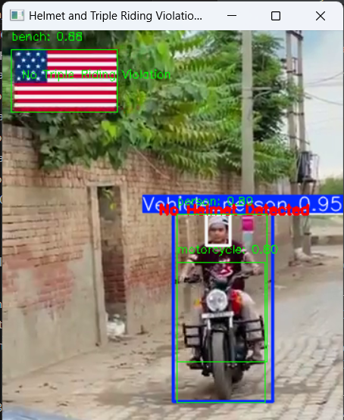

Fig. 24. Valid Detection

**Invalid Input**: Test with empty, blurred, or low-resolution images/videos to see if the system handles errors gracefully.

* On Image

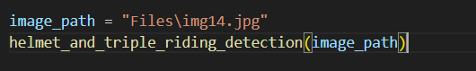

Fig.25. Given Empty Image Path

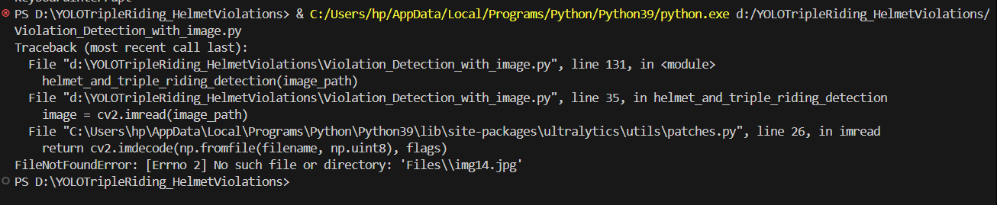

Fig.26. Displaying the Error Message

* On Video

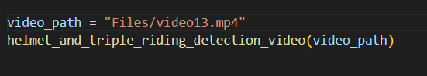

Fig.27. Given Empty Video Path



Fig.28. Displaying the Error Message

### **2. Object Detection Accuracy**

**Helmet Detection**:

* Single person wearing a helmet should be correctly detected.
* Multiple people wearing helmets all should be detected.
* Person without a helmet should be classified correctly.

**Triple Riding Detection**:

* Single rider should not flag a violation.
* Two riders should not flag a violation.
* Three or more riders should trigger a violation.

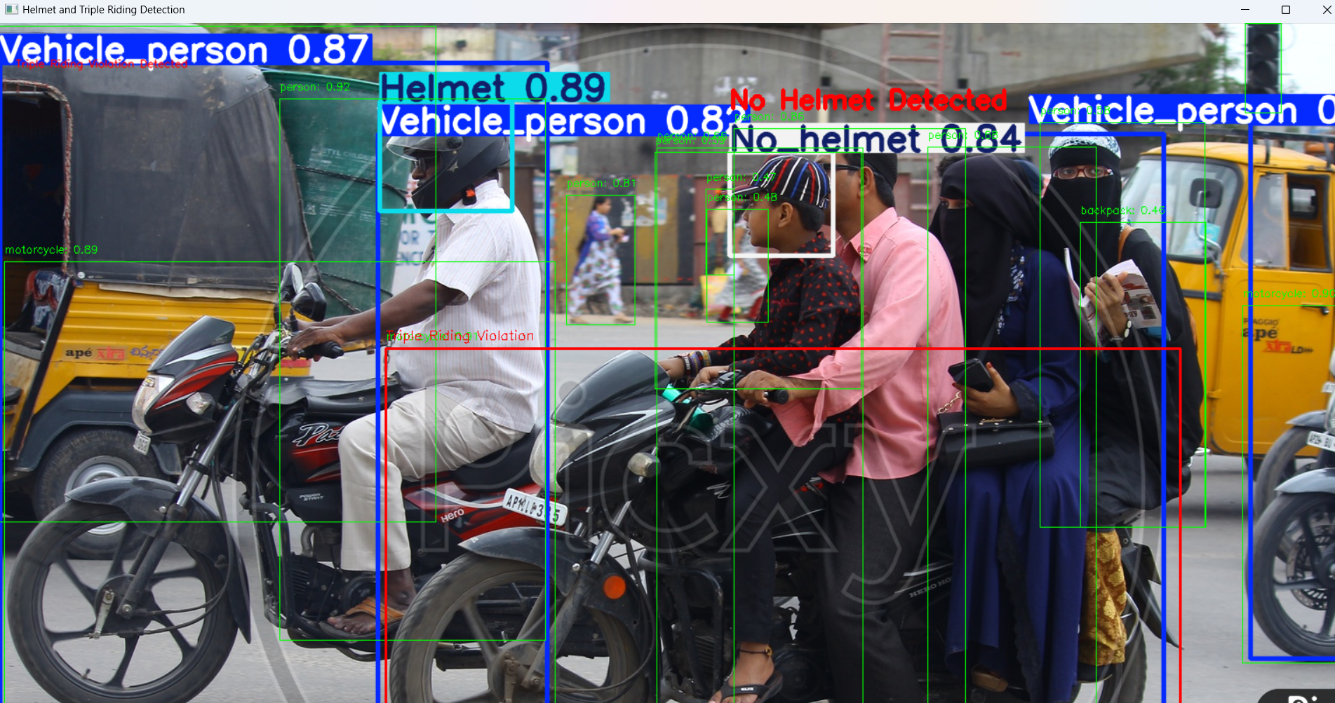

Fig.29. Accurate Detections of Violations

### **3. Edge Cases & Stress Testing**

**Occlusions**:

* Partial helmet visibility → should still detect as a helmet.
* Multiple riders wearing helmets but partially hidden → should be correctly identified.
* **Different Angles & Perspectives**: Side-view, top-view, back-view images → should detect correctly.
* **Heavy Traffic Scenarios**: Multiple bikes in one frame → system should differentiate between them.
* **Different Helmet Types & Colors**: Ensure detection is not biased toward specific colors or styles.

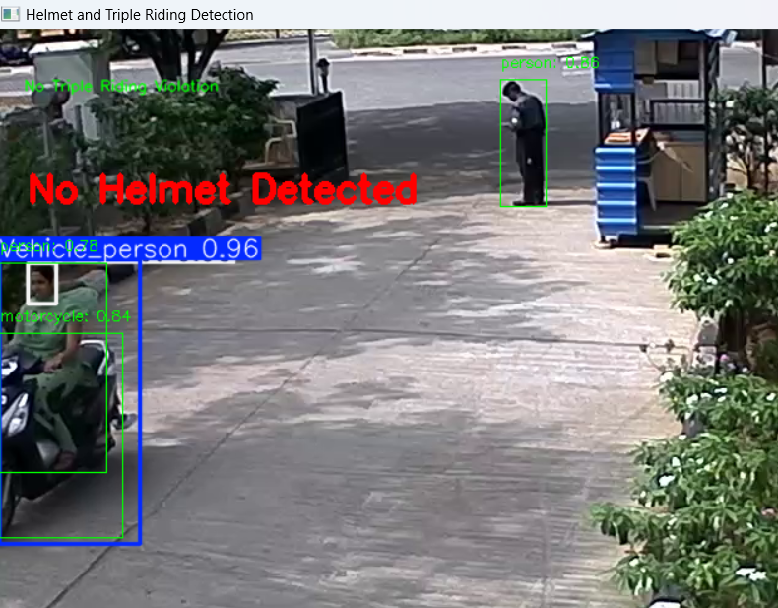

Fig.30. No helmet detected even in the low light condition

**6.4 Results**

**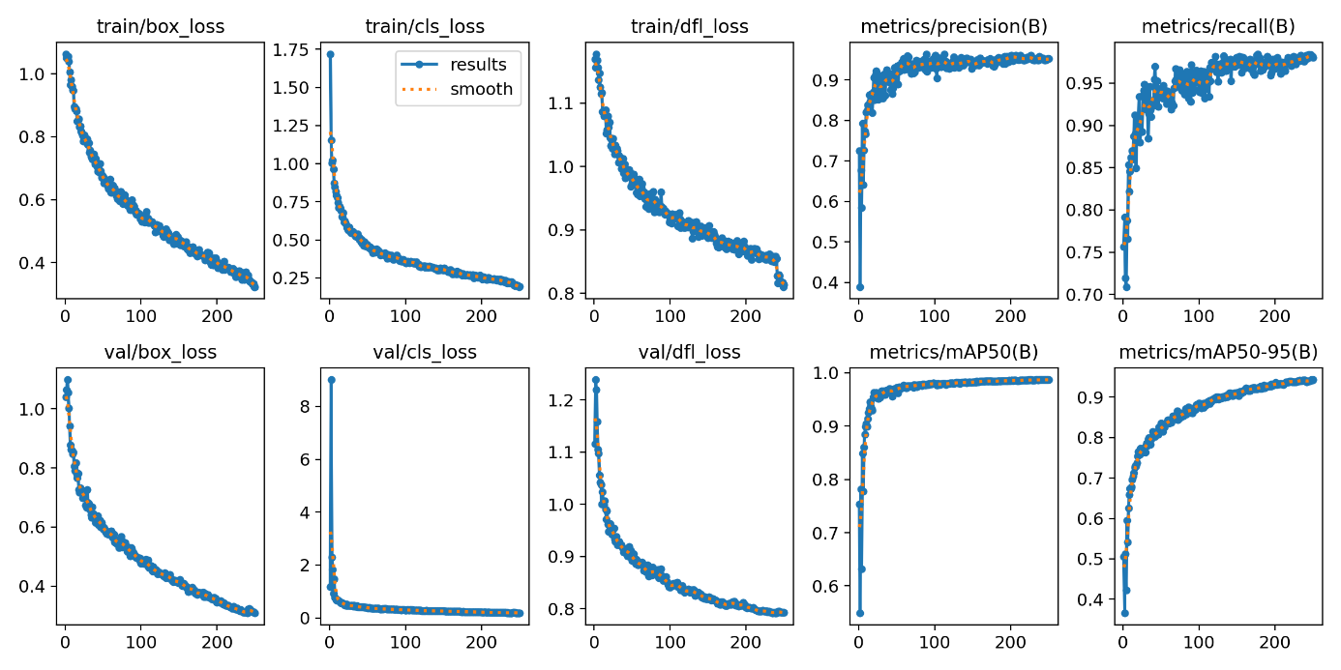**

Fig. 31. Results

The image displays training and validation performance metrics for a YOLO-based object detection model. The loss curves (box\_loss, cls\_loss, dfl\_loss) for both training and validation sets show a steady decline, indicating effective model learning. Precision and recall metrics improve over time, stabilizing around 0.9–0.95, signifying strong detection performance. The mAP50 (Mean Average Precision at IoU 0.5) reaches near 1.0, while mAP50-95 gradually improves, reflecting robust generalization across different IoU thresholds. Overall, the model exhibits convergence and high detection accuracy with minimal overfitting.

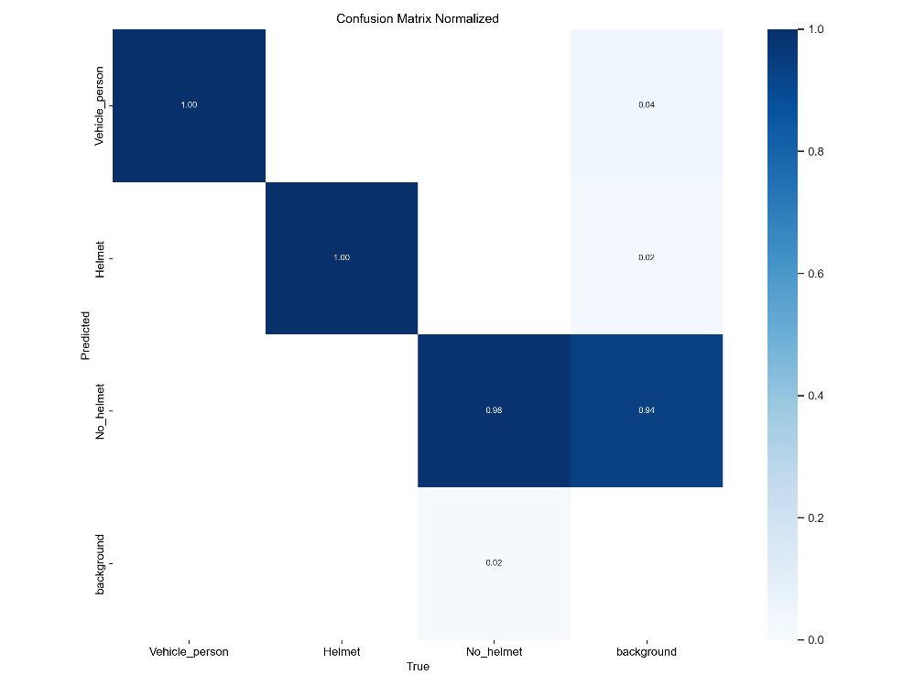

Fig. 32. Confusion matrix

The normalized confusion matrix evaluates the performance of a deep learning model for detecting vehicles with persons, helmets, and no-helmet cases. Each row represents the predicted class, while each column represents the true class. The diagonal values (1.00 for Vehicle\_person and Helmet, 0.98 for No\_helmet) indicate high accuracy in these categories. However, No\_helmet misclassifications occur with the background class (0.94), showing some false positives. Minimal confusion (0.02–0.04) exists between classes, indicating an overall well-performing model with slight background noise interference.

1. **CONCLUSION**

Traffic violations, particularly triple riding and helmet violations, pose a significant risk to road safety, contributing to severe accidents and fatalities. With the rapid urbanization and increasing number of vehicles on roads, manual monitoring of such violations is not only inefficient but also impractical. Traditional law enforcement methods rely heavily on human intervention, which is prone to errors, bias, and inefficiency. The advancement of deep learning and computer vision has opened new possibilities for intelligent, automated traffic monitoring systems that can detect violations with high precision and real-time accuracy. This project introduces an AI-driven traffic surveillance system that leverages YOLOv8 (You Only Look Once version 8), a cutting-edge deep learning object detection model, to detect triple riding and helmet violations using CCTV webcam footage. The system employs advanced computer vision techniques to process live video feeds, accurately detect riders, count the number of passengers, and determine whether they are wearing helmets. With an impressive 97% accuracy rate, this solution offers a robust and scalable approach to automating traffic rule enforcement while significantly reducing human intervention.

The proposed system has demonstrated remarkable achievements in terms of accuracy, efficiency, and scalability. The YOLOv8 deep learning model has been trained on an extensive dataset containing various traffic scenarios, ensuring high accuracy in detecting triple riding, helmet usage, and other infractions. Performance evaluation using key metrics like F1-score, precision, and recall confirms the system's reliability in distinguishing violations from compliant behaviors, with minimal false positives and false negatives. The system is capable of processing real-time CCTV footage, ensuring instant violation detection and enabling authorities to take swift action against offenders. Furthermore, the integration of Automatic Number Plate Recognition (ANPR) enables the system to automatically capture vehicle registration numbers, linking violations to specific individuals. This feature simplifies law enforcement by allowing authorities to issue fines directly to offenders, reducing manual workload and ensuring stricter compliance with traffic rules. Additionally, the system is designed to be scalable and deployable across different locations without requiring major modifications. It can be easily adapted to various road conditions, traffic densities, and environmental factors, making it a suitable solution for smart city infrastructure.

This project's key strength is automating law enforcement by generating fines and sending real-time violation alerts, reducing manual monitoring and improving road safety. However, challenges remain, including weather conditions and poor visibility affecting detection accuracy. To address this, image enhancement techniques or thermal imaging may be needed. Variations in traffic behaviour and road infrastructure require model retraining for adaptability, and expanding the dataset could enhance robustness. Occlusion in crowded traffic can hinder detection, which could be addressed with multi-camera setups and depth-sensing technologies. Additionally, optimizing the model for low-end hardware and edge devices would improve real-time processing.

To enhance the system's effectiveness, future improvements could include detecting additional traffic violations like over-speeding, signal violations, and lane discipline infractions through speed estimation and traffic signal monitoring. Integrating IoT and edge computing would enable decentralized, real-time processing on smart cameras, reducing latency. Predictive analytics using machine learning could allow for proactive traffic management by identifying potential violations.

Seamless integration with law enforcement would streamline fine issuance and tracking repeat offenders, while connecting to police databases could improve real-time violation tracking. Automated fine payment portals could also increase compliance. Finally, incorporating multi-sensor fusion with LiDAR, thermal imaging, and radar would improve detection in low-visibility conditions.

The deep learning-based traffic violation detection system, using YOLOv8, accurately identifies triple riding and helmet violations, offering a scalable, cost-effective solution for enhancing road safety. With further integration of emerging technologies like IoT, edge computing, and AI-driven analytics, this system can evolve into a fully autonomous traffic surveillance network that detects and prevents violations before accidents occur. The goal is to create a future-ready system that supports smart cities, ensuring safer roads, better compliance, and improved urban mobility.

1. **FUTURE SCOPE**

While significant progress has been made, challenges remain in achieving high accuracy under diverse conditions, such as varying lighting, occlusions, and high traffic density. Future research directions include enhancing model robustness, integrating license plate recognition for automated enforcement, and developing real-time alert systems to notify authorities of violations promptly.

In summary, the integration of deep learning techniques, particularly CNNs and advanced object detection frameworks like YOLO, has substantially improved the detection of helmet and triple riding violations. Ongoing research continues to address existing challenges, aiming to develop more efficient and reliable systems for traffic violation detection.

**1. Multiclass Violation Detection**

* Expand the system's functionality to detect other traffic violations, such as lane discipline violations, signal jumping, and overspeeding, by integrating additional datasets and training YOLO models for these specific tasks.
* Implement a multiclass classification system to identify and flag multiple violations simultaneously in a single frame.

**2. Real-Time Alert System**

* Develop a real-time alerting mechanism to notify law enforcement agencies instantly via SMS, email, or mobile applications about detected violations.
* Integrate with traffic management systems for issuing automated e-challans (electronic fines) to offenders based on the detected violations.

**3. Integration with License Plate Recognition**

* Combine the system with Optical Character Recognition (OCR) for license plate detection and recognition to link violations with vehicle registration details, aiding in enforcement and record-keeping.

**4. Improved Scalability**

* Enhance the system to process feeds from multiple CCTV cameras across different locations simultaneously, enabling large-scale deployment in urban areas.
* Optimize computational efficiency for deployment on edge devices like traffic monitoring cameras, reducing dependency on centralized servers.

**5. Adaptability to Challenging Conditions**

* Improve the robustness of the system by addressing challenges such as poor lighting, occlusions, and high traffic density.
* Utilize advanced data augmentation techniques and domain adaptation methods to train models that perform consistently across diverse weather, lighting, and environmental conditions.

**6. Use of Hybrid Models**

* Experiment with hybrid models by combining YOLO with transformer-based architectures or other state-of-the-art object detection frameworks to improve detection accuracy and speed.
* Explore the integration of models like ESRGAN for image enhancement to improve detection in low-resolution or blurry footage.

**7. Integration with Smart City Infrastructure**

* Incorporate the system into smart city initiatives, integrating it with traffic signal systems, pedestrian safety systems, and centralized traffic monitoring hubs.
* Enable real-time traffic flow analysis to dynamically adjust traffic rules and improve road safety.

**8. Data Privacy and Ethics**

* Ensure compliance with data privacy regulations by anonymizing captured data and restricting its use to traffic rule enforcement only.
* Implement ethical AI practices to prevent misuse of the system, such as limiting facial recognition to ensure individual privacy rights.

**9. Periodic Model Updates**

* Create a feedback mechanism to continuously update and retrain models using new data to adapt to changing road conditions, vehicle designs, and rider behaviors.
* Use active learning to involve human reviewers in improving detection accuracy by validating edge cases flagged by the system.

**10. Public Awareness and Engagement**

* Introduce mobile applications or public portals that allow individuals to view and rectify their violations, fostering a sense of accountability.
* Use the system's analytics to inform public safety campaigns by identifying areas with high violation frequencies and tailoring interventions accordingly.

By implementing these enhancements, the system can evolve into a comprehensive traffic monitoring and management solution, significantly contributing to road safety and compliance with traffic regulations.

1. **BIBLIOGRAPHY**
   1. Nikhil Chakravarthy Mallela, Rohit Volety, Srinivasa Perumal R., Nadesh R. K., ‘Detection of the triple riding and speed violation on two-wheelers using deep learning algorithms’, Multimedia Tools and Applications, 80(6), 8175-8187.
   2. Kisaezehra, M. Umer Farooq, M. Aslam Bhutto, and A. Karim Kazi, ‘Real-time safety helmet detection using Yolov5 at construction sites’, Intell. Autom. Soft Comput., vol. 36, no. 1, pp. 911–927, 2023.
2. Y.-J. Zhang, F.-S. Xiao, and Z.-M. Lu, ‘Helmet Wearing State Detection Based on Improved YOLOv5s’ Sensors, vol. 22, no. 24, p. 9843, Dec. 2022.
3. J. Chen, S. Deng, P. Wang, X. Huang, and Y. Liu, ‘Lightweight helmet detection algorithm using an improved YOLOv4’, Sensors (Basel), vol. 23, no. 3, p. 1256, Jan. 2023.
4. J. Redmon, S. Divvala, R. Girshick, and A. Farhadi, ‘You only look once: Unified, re-al-time object detection’, in 2016 IEEE Conference on Computer Vision and Pattern Recognition (CVPR), Las Vegas, NV, USA, 2016.
5. P. F. Felzenszwalb, R. B. Girshick, D. McAllester, and D. Ramanan, ‘Object detection with discriminatively trained part-based models’, IEEE Trans. Pattern Anal. Mach. In-tell., vol. 32, no. 9, pp. 1627–1645, Sep. 2010.
6. J. Han, Y. Liu, Z. Li, Y. Liu, and B. Zhan, ‘Safety helmet detection based on YOLOv5 driven by super-resolution reconstruction’, Sensors (Basel), vol. 23, no. 4, Feb. 2023.
7. H. Bian et al., ‘Detection method of helmet wearing based on UAV images and Yolov7’, in 2023 IEEE 6th Information Technology, Networking, Electronic and Automation Control Conference (ITNEC), Chongqing, China, 2023.
8. P. Tripathi, P. Singh, M. Bano, K. Sharma, and A. Shahi, ‘A review on helmet and number plate detection’, Int. J. Res. Publ. Rev., vol. 4, no. 5, pp. 2473–2484, May 2023.J. Han, Y. Liu, Z. Li, Y. Liu, and B. Zhan, ‘Safety helmet detection based on YOLOv5 driven by super-resolution reconstruction’, Sensors (Basel), vol. 23, no. 4, Feb. 2023.
9. A. Q. Abd, H. R. Farhan, M. Kod, and K. R. Singh, ‘An Efficient System for Detecting Multiple Traffic Violations and Recognizing License Plates Using Video Processing and Deep Learning’ *Int. J. Electr. Electron. Eng. Telecommun.*, vol. 13, no. 5, pp. 406–414, Sep. 2024.

**10. APPENDIX**

**10.1 Appendix-A**

**Project Repository Details**

**Project Title:** A Deep Learning-Based System to Detect Triple Riding and Helmet Violations Through CCTV Webcam

**Batch:** B4

**Batch Members:**

1. MADDINENI KAVYA - 21B01A0591

2. MARISETTI HEMA SRI - 21B01A0598

3. K. SAI VENKATA SAHITHI - 21B01A0586

4. LAVUDIA HARSHITHA - 21B05A0590

5. MAJJI TEJASWI - 21B01A0592

**Department:** Computer Science and Engineering

**Institution:** Shri Vishnu Engineering College For Women

**Guide:** Dr. T. Gayathri

**Submission Date:**

**Project Repository Link**

The complete project files, including source code, documentation, and additional resources, are available at the following GitHub repository:

**GitHub Repository:** <https://github.com/kavyamaddineni/A_Deep_Learning_Based_System_To_Detect_Triple_Riding_and_Helmet_Violations_Through_CCTV_Webcam>

### **10.2 Dataset Description for Helmet Detection**

The dataset used for the helmet detection system is a curated collection of annotated images, designed specifically to train and evaluate the YOLOv8 model for detecting helmet and no-helmet scenarios. Below is a detailed breakdown of the dataset and its characteristics:

**1. Dataset Overview**

* **Total Images:** Approximately 600 images.
* **Image Format:** Common image formats like JPEG and PNG.
* **Resolution:** Images vary in resolution, ensuring diversity and robustness.
* **Annotations:** Each image is annotated using the LabelImg tool in YOLO-compatible format.
* **Classes:**
  + Vehicle\_person: Represents motorcycles and riders.
  + Helmet: Identifies individuals wearing helmets.
  + No\_helmet: Identifies individuals not wearing helmets.

**2. Data Sources**

* **Captured Data:** Images are collected from various sources, including publicly available datasets and custom captures using traffic surveillance cameras.
* **Diversity:**
  + Urban and rural traffic scenarios.
  + Day and night images to address varying lighting conditions.
  + Images with different densities of vehicles and riders.

**10.3 Introduction to Opencv**

****

Fig. 31. Opencv

OpenCV (Open Source Computer Vision Library) is released under a BSD license and hence it’s free for both academic and commercial use. It has C++, Python and Java interfaces and supports Windows, Linux, Mac OS, iOS and Android. OpenCV was designed for computational efficiency and with a strong focus on real-time applications. Written in optimized C/C++, the library can take advantage of multi-core processing. Enabled with OpenCL, it can take advantage of the hardware acceleration of the underlying heterogeneous compute platform.

OpenCV (Open Source Computer Vision Library) is an open source computer vision and machine learning software library. OpenCV was built to provide a common infrastructure for computer vision applications and to accelerate the use of machine perception in the commercial products. Being a BSD-licensed product, OpenCV makes it easy for businesses to utilize and modify the code.

The library has more than 2500 optimized algorithms, which includes a comprehensive set of both classic and state-of-the-art computer vision and machine learning algorithms. These algorithms can be used to detect and recognize faces, identify objects, classify human actions in videos, track camera movements, track moving objects, extract 3D models of objects, produce 3D point clouds from stereo cameras, stitch images together to produce a high resolution image of an entire scene, find similar images from an image database, remove red eyes from images taken using flash, follow eye movements, recognize scenery and establish markers to overlay it with augmented reality, etc. OpenCV has more than 47 thousand people of user community and estimated number of downloads exceeding 14 million. The library is used extensively in companies, research groups and by governmental bodies.

OpenCV has a modular structure, which means that the package includes several shared or static libraries. The following modules are available:

* Core functionality (core) - a compact module defining basic data structures, including the dense multi-dimensional array Mat and basic functions used by all other modules.
* Image Processing (imgproc) - an image processing module that includes linear and non-linear image filtering, geometrical image transformations (resize, affine and perspective warping, generic table-based remapping), color space conversion, histograms, and so on.
* Video Analysis (video) - a video analysis module that includes motion estimation, background subtraction, and object tracking algorithms.
* Camera Calibration and 3D Reconstruction (calib3d) - basic multiple-view geometry algorithms, single and stereo camera calibration, object pose estimation, stereo correspondence algorithms, and elements of 3D reconstruction.
* 2D Features Framework (features2d) - salient feature detectors, descriptors, and descriptor matchers.
* Object Detection (objdetect) - detection of objects and instances of the predefined classes (for example, faces, eyes, mugs, people, cars, and so on).
* High-level GUI (highgui) - an easy-to-use interface to simple UI capabilities.
* Video I/O (videoio) - an easy-to-use interface to video capturing and video codecs.
* Some other helper modules, such as FLANN and Google test wrappers, Python bindings, and others.

**Automatic Allocation of the Output Data**

* OpenCV deallocates the memory automatically, as well as automatically allocates the memory for output function parameters most of the time. So, if a function has one or more input arrays (cv::Mat instances) and some output arrays, the output arrays are automatically allocated or reallocated. The size and type of the output arrays are determined from the size and type of input arrays. If needed, the functions take extra parameters that help to figure out the output array properties.
* The array frame is automatically allocated by the >> operator since the video frame resolution and the bit-depth is known to the video capturing module. The array edges is automatically allocated by the cvtColor function. It has the same size and the bit-depth as the input array. The number of channels is 1 because the color conversion code cv::COLOR\_BGR2GRAY is passed, which means a color to grayscale conversion. Note that frame and edges are allocated only once during the first execution of the loop body since all the next video frames have the same resolution. If you somehow change the video resolution, the arrays are automatically reallocated.
* Getting started with OpenCV's Python bindings is actually much easier than many people make it out to be initially. You will need two main libraries, with an optional third: python-OpenCV, Numpy, and Matplotlib.

**Windows Users:**

* [python-OpenCV](https://www.lfd.uci.edu/~gohlke/pythonlibs/#opencv) - There are alternative methods, but this is the easiest. Download the appropriate wheel (.whl) file, and install using pip. See video for help.
* pip install numpy
* pip install matplotlib
* Not familiar with using pip? See the [Pip installation tutorial](https://pythonprogramming.net/using-pip-install-for-python-modules/) for help.

**Linux / Mac Users:**

* pip3 install numpy or apt-get install python3-numpy. You may need to apt-get install python3-pip.
* pip3 install matplotlib or apt-get install python3-matplotlib.
* apt-get install python3-OpenCV

[Matplotlib](https://pythonprogramming.net/matplotlib-intro-tutorial/) is an optional choice for displaying frames from video or images. We will show a couple of examples using it here. [Numpy](https://www.numpy.org/" \t "_blank) is used for all things "numbers and Python." We are mainly making use of Numpy's array functionality. Finally, we are using the python-specific bindings for OpenCV called python-OpenCV.

There are some operations for OpenCV that you will not be able to do without a full installation of OpenCV (about 3GB in size), but you can actually do quite a bit with the fairly minimal installation of python-OpenCV. We will wind up using the full installation of OpenCV later in this series, so you can feel free to get it if you like, but these 3 modules will keep us busy for a while!

**10.4 Introduction to Python Programming**

****

Fig. 32. Python programming

Python is an interpreted, high-level, general-purpose programming language. Created by Guido van Rossum and first released in 1991, Python has a design philosophy that emphasizes code readability, notably using significant whitespace. It provides constructs that enable clear programming on both small and large scales. Van Rossum led the language community until stepping down as leader in July 2018.Python features a dynamic type system and automatic memory management. It supports multiple programming paradigms, including object-oriented, imperative, functional and procedural. It also has a comprehensive standard library. The Python interpreter and the extensive standard library are freely available in source or binary form for all major platforms from the Python Web site, https://www.python.org/, and may be freely distributed. The same site also contains distributions of and pointers to many free third party Python modules, programs and tools, and additional documentation.

 Python is simple to use, but it is a real programming language, offering much more structure and support for large programs than shell scripts or batch files can offer. On the other hand, Python also offers much more error checking than C, and, being a very-high-level language, it has high-level data types built in, such as flexible arrays and dictionaries. Because of its more general data types Python is applicable to a much larger problem domain than Awk or even Perl, yet many things are at least as easy in Python as in those languages.

Python allows you to split your program into modules that can be reused in other Python programs. It comes with a large collection of standard modules that you can use as the basis of your programs — or as examples to start learning to program in Python. Some of these modules provide things like file I/O, system calls, sockets, and even interfaces to graphical user interface toolkits like Tk.

Python is an interpreted language, which can save you considerable time during program development because no compilation and linking is necessary. The interpreter can be used interactively, which makes it easy to experiment with features of the language, to write throw-away programs, or to test functions during bottom-up program development. It is also a handy desk calculator.

Python enables programs to be written compactly and readably. Programs written in Python are typically much shorter than equivalent C, C++, or Java programs, for several reasons:

* the high-level data types allow you to express complex operations in a single statement;
* statement grouping is done by indentation instead of beginning and ending brackets;
* no variable or argument declarations are necessary.

Python is extensible: if you know how to program in C it is easy to add a new built-in function or module to the interpreter, either to perform critical operations at maximum speed, or to link Python programs to libraries that may only be available in binary form (such as a vendor-specific graphics library). Once you are really hooked, you can link the Python interpreter into an application written in C and use it as an extension or command language for that application.

**Invoking the Interpreter**

The Python interpreter is usually installed as /usr/local/bin/python3.7 on those machines where it is available; putting /usr/local/bin in your Unix shell’s search path makes it possible to start it by typing the command:

Python 3.7

To the shell. [[1]](https://docs.python.org/3.7/tutorial/interpreter.html#id2) Since the choice of the directory where the interpreter lives is an installation option, other places are possible; check with your local Python guru or system administrator. (E.g., /usr/local/python is a popular alternative location.)

On Windows machines, the Python installation is usually placed in C:\Python37, though you can change this when you’re running the installer. To add this directory to your path, you can type the following command into the command prompt in a DOS box:

Typing an end-of-file character (Control-D on Unix, Control-Z on Windows) at the primary prompt causes the interpreter to exit with a zero exit status. If that doesn’t work, you can exit the interpreter by typing the following command: quit().

The interpreter’s line-editing features include interactive editing, history substitution and code completion on systems that support readline. Perhaps the quickest check to see whether command line editing is supported is typing Control-P to the first Python prompt you get. If it beeps, you have command line editing; see Appendix Interactive Input Editing and History Substitution for an introduction to the keys. If nothing appears to happen, or if ^P is echoed, command line editing isn’t available; you’ll only be able to use backspace to remove characters from the current line.

The interpreter operates somewhat like the Unix shell: when called with standard input connected to a tty device, it reads and executes commands interactively; when called with a file name argument or with a file as standard input, it reads and executes a script from that file. A second way of starting the interpreter is python -c command [arg] ..., which executes the statement(s) in command, analogous to the shell’s [-c](https://docs.python.org/3.7/using/cmdline.html#cmdoption-c) option. Since Python statements often contain spaces or other characters that are special to the shell, it is usually advised to quote command in its entirety with single quotes. Some Python modules are also useful as scripts. These can be invoked using python -m module [arg] ..., which executes the source file for module as if you had spelled out its full name on the command line. When a script file is used, it is sometimes useful to be able to run the script and enter interactive mode afterwards. This can be done by passing [-i](https://docs.python.org/3.7/using/cmdline.html#cmdoption-i) before the script.